Early Childhood Development Curriculum
Facilitators’ Guide
Haiti Edition

“All children have the right to affection, love and understanding”
UN Declaration on the Rights of the Child

© 2015 Hands to Hearts International
Sections of this book may be reproduced, translated or adapted with minor changes to meet local needs, provided they are distributed free or at cost and not for profit and provided that any changes maintain the integrity of the book. Please send any translations of these materials to Hands to Hearts International, email 1 copy to laura@handstohearts.org. All translations will be freely shared on HHI’s website.

About Hands to Hearts International
Hands to Hearts International (HHI) improves the lives of young children by training parents/caregivers about early childhood development, and nurturing parenting skills. Caregivers are empowered with the skills to better their child’s health, brain development and early learning by engaging in a variety of skill-building exercises based on knowledge of early childhood development milestones as well as health, hygiene, nutrition and sanitation. In ten years, HHI served 200,000 moms, dads and babies.
Learn more at www.handstohearts.org

Acknowledgments
HHI would like to thank the following people and organizations for making this work possible:
The Greenbaum Foundation
The Good Works Institute, Inc.
The Alliance for Children Foundation
Reach India
Sujatha Balaje, Christine Chaillé, Sue Glassford, Frank Mahler, and Laura Peterson
Preface
Early childhood development interventions—those targeting children from birth to age 5—are among the most cost-effective approaches for improving outcomes for vulnerable and at-risk children (Cunha and Heckman, 2007; Fernald, Kariger, Engle & Raikes, 2009).
For families battling hunger, poverty, violence and disease, it can be a struggle to provide a baby’s most basic need: love. Children who are not nurtured during the critical first five years of life face emotional, physical, social and cognitive problems that can severely hinder their ability to thrive, if they even survive.
This Facilitators’ Guide for Early Childhood Development was designed to be used in low-resource, low literacy areas. It contains a number of sessions and materials specifically designed to prepare Facilitators of parents and caregivers to support children during their early and most critical developmental time.

Table of Contents
About this Facilitators’ Guide 2
Session #1: Know Your Baby’s Brain 3
Welcome and Review 3
Practice the New Content 8
Apply the New Content at Home 9
Session #2: Baby Cues 12
Welcome and Review 12
Introduce the New Content 13
Practice the New Content 16
Apply the New Content at Home 17
Session #3: Language Development 19
Welcome and Review 19
Introduce the New Content 20
Practice the New Content 21
Apply the New Content at Home 24
Session #4: Social and Emotional Development 26
Welcome and Review 26
Practice the New Content 30
Apply the New Content at Home 32
Session #5: Physical Development 36
Welcome and Review 36
Introduction to New Content 37
Practice the New Content 41
Apply the New Content at Home 43
Session #6: Developing the Thinking Pathways 45
Welcome and Review 45
Practice the New Content 50
Apply the New Content at Home 51
Session #7: Baby Massage 52
Welcome and Review 52
Apply the New Content at Home 60
Session #8: Basic Health, Hygiene, Safety and Nutrition 65
Welcome and Review 65
Introduce the New Content, Part 1 66
Introduce the New Content, Part 2 67
Guidance for Using the Training Delivery Observation Form for Quality Control 75
Conclusion 78
Resources 79

About this Facilitators’ Guide
Early Childhood Development: Birth through Age 3
How to Use the Module
This guide has eight sessions. These sessions need to be delivered in order, in their entirety. The objectives, preparation and steps for each session are clearly and completely detailed to assist Facilitators in implementing effectively and confidently. The guide contains all the pictures required in each session.
Features of the Guide’s Sessions

Information Box. The box at the start of each session contains the following similar information:
- Objectives—A statement about what the participants should accomplish in each session
- Materials—A list of actions or materials that must be ready before the session can be presented
Steps. Each session has four steps—Welcome and Review, Introduce the New Content, Practice the New Content, Apply the New Content at Home. The steps are listed in the order recommended for implementation. Special features for the Facilitator to note include the following:
- Italic font = instructions for the Facilitator (not read to the participants)
- Regular font = specific information or instructions for the Facilitator to read or closely paraphrase to the participants
- Bold font and arrow () = specific question to ask the participants
Each session is designed to:
- Encourage participants to use their life experience to understand the concepts and ideas contained in the session.
- Present new content in an engaging way.
- Provide participants with an opportunity to apply or practice the new content during the session.
- Prepare to use the new content in their day-to-day interactions with the children in their care.
Although sessions may require adaptations according to the number of participants or the availability of suggested materials, it is important to follow the guide as closely as possible. Omitting any of the activities within a session, particularly activities which involve practicing the new content, will limit the caregivers’ ability to practice the new ideas and behaviors with the children in their care.

Session #1: Know Your Baby’s Brain
Objectives. By the end of the session, participants will have:
- Answered true/false questions
- Observed a demonstration of how a simple interaction between caregiver and child supports brain development
- Listened to a description of how learning pathways are created in the brain from birth, and identified how they help to create these pathways
- Identified behaviors that do and behaviors that don’t support brain development
- Decided one thing to do at home with children below the age of 3 to support their brain development
- Practiced the “Four Pathways” song

Materials:
- True/False Survey
- Picture of learning paths
- Two brooms
- The “Four Pathways” song (Song lyrics, gestures and melody that were created during the Trainer of Trainers)

Time: 60 minutes

Welcome and Review
Have a copy of the True/False Survey ready to record the participants’ responses. Bring this survey to all eight sessions until it is complete.
Say: Welcome to the first of our eight sessions together on Early Childhood Care and Development for children from birth to age 3.
At the beginning of each session, I’ll ask you true/false questions. Here are today’s questions. Cover your eyes with one hand and raise your other hand if you think the statement is true.
True or false: There are simple things I can do every day with babies and children to help them develop their brains.
True or false: The fastest and most important brain development happens when a child goes to school.
Count the number of raised hands. Record it in the “Before Session” column in the True/False Survey (found at the end of this session).
Say: Today’s session is called “Know Your Baby’s Brain.” Let me start with a story.
Say: Rozalie, Joulie, Nadege, Renaud and Telly were asked, “What do you want for your children?” Listen to their answers.
(Note to Facilitator: Change names as needed to reflect common names in your community.)
Rozalie said | I want them to be clean and healthy.
Joulie said | I want them to be able to read so they can find information and better jobs.
Nadege said | I want them to grow up to be loving and caring and to have good relationships with others.
Renaud said | I want them to believe in themselves and have confidence.
Telly said | I want them to have a chance to do well in school.

- Ask: Which of these do you want for the children in your care?
Listen to their answers.
Say: I have good news, then! You can help children achieve that by helping their brains become bigger and stronger from the time they are born until they are 3 years old. This is when our brains grow the most. You can help a baby’s brain grow and become stronger by doing a few simple things every day. Today, we’ll practice these brain strengthening activities. We’ll start with sharing what you do with your children every day.
- Ask: Think about a typical day with a baby or child under 3 years old. What are the important things you do for or with her throughout the day?
Summarize their responses. Praise the participants for the care they are already showing their babies.
Say: As you do these everyday activities, your child is learning and it makes her brain bigger and stronger. Here’s an example of how something you do helps your baby to learn. Everyone pretend to hold a baby (use a real and willing baby, if possible) and repeat my actions.
Make sure the baby is comfortable. Look into her eyes and smile. As you do this, the baby’s brain is learning what love and care feels like. This helps the brain to show love and caring to others, and it can help her feel more confident.
Begin to gently sway with the baby. This swaying movement is helping the baby’s brain to learn about moving her own body.
- Ask: What are some songs we can sing or things we can say to her as we rock her?
Listen for suggestions.
Say: Let’s do some of your suggestions for talking and singing.
Allow a minute or two for talking and singing.
Say: Our talking and singing is teaching the baby’s brain to recognize and make sounds that will become words when she is older. Hearing words prepares your baby to learn to read in a few years.
- Ask: Listen, what is our baby hearing? What is she seeing? What might she be smelling?
Listen to and affirm their answers.
Say: All these things are teaching her brain to recognize sounds, sights and smells. Being able to recognize things is how we begin to develop our thinking skills.
This is because our swaying, singing and looking at our baby is creating learning paths in her brain.
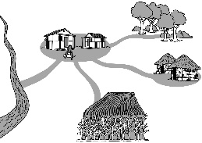
Show the learning paths to the participants.
Trace the paths on the picture as you explain them.

Say: Some of these paths are for creating language so your child will eventually be able to speak and read. Other paths are for thinking. Some paths are for physical movement. And the last paths are for developing confidence and for feeling a loving and caring connection to others. Notice that all the paths are connected. They work together. To create a path in a village, we have to walk the same route over and over again. This is the same for your child’s brain. She has to do the same actions or have the same experience over and over in order to create a learning path in her brain.

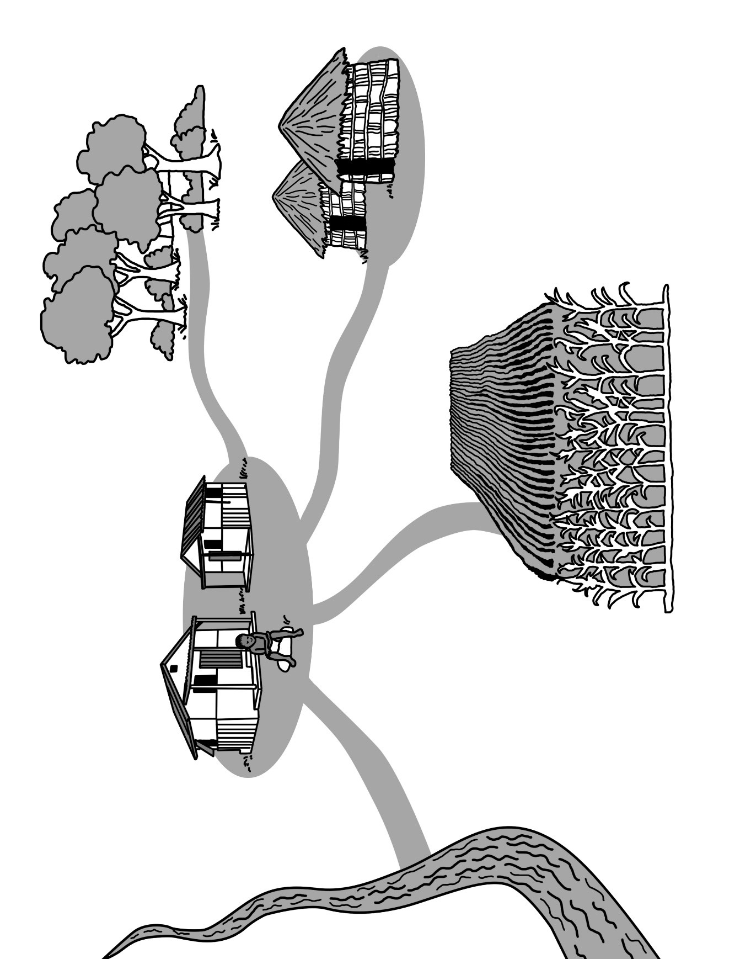

- Ask: What is something you see your babies or children doing over and over again?
Listen to their responses.
Say: That’s your baby or child developing a pathway for (name one of the domains depending on the example the participant provides, such as):
- Learning a game (Thinking)
- Stacking things and knocking them down (Physical)
- Making sounds (Language)
Say: Second, anyone—a man, a woman or an older child—can help to create a path in the village. Men, women and older children can also help younger children create learning paths by doing things with them.
- Ask: Who does your baby or child interact with most each day? Who else other than you?
Summarize their responses and affirm that all these people can interact with small children in ways that help to create learning paths.
Say: Third, the path won’t be used if it is frightening. If a child is surrounded by anger, violence and harsh words, instead of kindness, love and caring, the paths can’t properly develop.
- Ask: What questions do you have about the pathways?
Address any questions.
Say: Let’s sing a song (or poem) together to help us remember the four main pathways.
Sing the song (or say the poem) incorporating gestures that you prepared, repeating it until the participants have learned it.
Prepare the song lyrics, gestures and melody before this session, making sure the lyrics express the following ideas:
- I will talk to you so you learn to speak (touch your mouth).
- I will show you things so you learn to think (touch your head).
- I will let you move so you can learn to move on your own (make a gesture that shows strength).
- I will treat you with kindness, love and caring so you treat others the same and believe in yourself (touch your heart).
- You can trust me to strengthen your body and brain.
“Four Pathways” song
________________________________________________________________________________________________________________________________________________________________________________________________________________________________________________________________________________________________________________________________________________________________________________________________________________________________________________________________________________________________________________________________________________________
___________________________________________________________________
(*Watch a video of this song in Creole, created in Haiti https://youtu.be/cK_Wvc_DPbo )

Practice the New Content
Say: Let’s practice recognizing how our everyday actions help a child’s brain develop.
When two volunteers come forward, affirm their participation.
Say: These are my two children. They are 2 years old and are enjoying playing with a broom, moving it like they are sweeping.
Watch me and describe what I am doing with each child.
Ask the two volunteers to begin to sweep. Talk to one child as she sweeps. Use an encouraging tone. Ask her to make big and small movements or to sweep one area or another. With the other child, say very little and mostly ignore her. Tell her that she is just making a mess and take the broom away from her.
At the end of the demonstration, ask the following question.
- Ask: What did you see me do?
- Which of my actions help to create paths in the brain for physical movement, language or thinking skills or to feel loved and cared about?
Listen and affirm or clarify their suggestions.
Say: Let’s imagine other situations.
- Ask: What are other activities you do every day?
Listen to the participants’ suggestions and pick one example of an everyday activity to demonstrate. Ask one participant to be an infant, another to be a 2-year-old and a third participant to play a 3-year-old.
Say: We’ll do a demonstration together. Watch what we do and identify if I’m doing anything to help develop the learning paths in my children’s brains.
Demonstrate the suggested activity. For example, if the suggestion is “prepare breakfast,” demonstrate how you can talk to the infant as you prepare breakfast and give her something to shake, ask the 2-year-old to point to food as you name it and to try to say it, and ask the 3-year-old to put the spoons and bowls for everyone on the table.
At the end of the demonstration, ask the following question.
- Ask: What did you see me do with the children that supports their brain development?
Summarize and affirm their answers.
- Ask: What are other things that I could do?
Summarize and affirm their suggestions.
Say: Let’s imagine we are going to the market. Who will volunteer to be my three children?
Demonstrate talking to the infant as you travel to the market. Introduce all your children to the sellers and encourage them to give a proper greeting. Ask the 2-year-old to point to a food as you name it and to try to say it. Encourage your 3-year-old to count the items you buy and to describe an item as light or heavy; as something you eat or not, or by other characteristics of the item. The market is a great place to touch, smell, see and talk about many different things!
At the end of the demonstration, ask the following question.
- Ask: What did you see me do with the children that supports their brain development?
Summarize and affirm their suggestions.

Apply the New Content at Home
Say: Thank you for your participation. I hope you enjoyed learning about your child’s brain. Before you leave, let’s share something we can do at home.
- Ask: What is something you do every day with or for children in your care who are under the age of 3?
- Ask: What is one simple thing you can do during that activity to help the children develop a bigger, stronger brain?
Affirm their suggestions.
Say: Let’s revisit two of the true/false questions. Think about what you learned today and listen to them again. Cover your eyes with one hand and raise your other hand if you think the statement is true.
True or false: There are simple things I can do every day with babies and children to help them develop their brains.
True or false: The fastest and most important brain development begins when a child goes to school.
- Count the number of raised hands and record the number in the “After Session” column of the True/False Survey. Record the total number of participants in today’s session in the “Number of Participants (Originally)” column.
- Ask: What did you learn today that you will try with your children before the next session?
Affirm their suggestions and encourage their willingness to try.
Say: Babies and children also need peace and quiet. You don’t need to constantly interact with your child. Watch your children and notice when they want to be quiet and peaceful with you or want to play on their own and when they want your company and attention. In our next session, you will learn more about what babies are trying to tell you before they are able to speak.
Close by singing the “Four Pathways” song one more time, and thank them for their participation. Be sure to write down the number of participants in the appropriate cell of the True/False Survey.

True/False Survey
Session # and Subject | Assessment Question and Answer | Before Session  T/F | After Session  T/F | After Session #8  T/F | Number of Participants (originally)
1  Know Your Baby’s Brain | There are simple things I can do every day with babies and children to help them develop their brains. (TRUE) | T=  F= | T=  F= | T=  F=
1  Know Your Baby’s Brain | The fastest and most important brain development happens begins when a child goes to school. (FALSE) | T=  F= | T=  F= | T=  F=
2  Baby Cues | Before a child speaks, the only way the child communicates is by crying. (FALSE) | T=  F= | T=  F= | T=  F=
3  Language | If you talk to children regularly before the age of 1, they will know more words, find it easier to learn to read and do better in school. (TRUE) | T=  F= | T=  F= | T=  F=
4  Socio-Emotional | If you consistently treat babies with love and care, their brains and bodies become bigger and stronger. (TRUE) | T=  F= | T=  F= | T=  F=
5  Physical | When you play games with children, you are developing their bodies and their brains. (TRUE) | T=  F= | T=  F= | T=  F=
5  Physical | A child’s everyday actions such as grabbing, holding, pushing, crawling and walking show us that the baby’s brain is developing. (TRUE) | T=  F= | T=  F= | T=  F=
6  Thinking | Children and adults experience the world in the same way. (FALSE) | T=  F= | T=  F= | T=  F=
6  Thinking | Babies develop their thinking skills with their hands and their mouths. (TRUE) | T=  F= | T=  F= | T=  F=
7  Massage | Massaging a baby is one way of showing love and caring. (TRUE) | T=  F= | T=  F= | T=  F=
7  Massage | If you talk to a baby during a massage, you are developing both her language skills and physical skills. (TRUE) | T=  F= | T=  F= | T=  F=
8  Health | Hand-washing and the cleanliness of floors, diapers, bottles and bedsheets affect the health of children and their caregivers. (TRUE) | T=  F= | T=  F= | T=  F=

Session #2: Baby Cues
Objectives. By the end of the session, participants will have:
- Described how adults communicate their feelings without using words
- Described how babies communicate without using words
- Decided which baby cues mean “yes” and which mean “no”
- Practiced identifying cues in day-to-day interactions and how to respond positively to the cue
- Explained how they will use baby cues in their lives

Materials:
- True/False Survey, which you used in previous session
- An object, such as a pen
- Six packages of yes/no baby cue cards (one package per group)

Time: 60 minutes

Welcome and Review
Say: Welcome to our second meeting. During our last session, we discussed actions you can take every day to help your children have bigger and stronger brains. We also sang a song to remember the four types of learning paths.
- Ask: Who can lead us through the song?
Encourage participants to sing the song and make the gestures.
Say: We’ll begin this session with a true/false question. Cover your eyes with one hand and raise your other hand if you think the statement is true.
True or false: Before a child speaks, the only way the child communicates is by crying.
Count the number of raised hands. Record it in the “Before Session” column in the True/False Survey (found at the end of this session).
Say: In this session, we are going to explore the different ways babies communicate with you before they are able to speak. Let’s start with this question.
- Ask: Think of when your husband or wife comes home. If they don’t say anything, how do you know if they had a good or bad day?
Listen to their responses.
Say: This is similar with babies. Even though babies can’t talk, they are still communicating their feelings and needs to us. Let’s look at an example.
Ask a participant to act like a baby who can’t roll over or speak yet (alternatively, act it out yourself). Place a mat or towel on the floor and have the volunteer lie on her back. Place an object, such as a pen, close to the volunteer but slightly too far away to reach.
Say: (Volunteer’s name) is a baby who can’t roll over or speak yet.
- Ask: “(volunteer’s name), how can you get that pen if you can’t roll over and can’t speak?” Show me.
Watch as the volunteer acts out how to try and get the pen (for example, volunteer looks at the pen again and again and tries to reach for it).
- Ask: What is (volunteer’s name) doing? How is she trying to communicate?
Listen to a few responses. Encourage the volunteer to continue to try to find a way to get the pen, as a baby would. (Unable to get the pen on her own, the volunteer cues for distress will increase. The only way the volunteer will be able to get the pen is to signal to someone else, the caregiver, that she wants it. Usually, in the exercise, the volunteer will eventually imitate crying.)
- Ask: What did (volunteer’s name) do to eventually signal to her caregiver that she wanted help?
Ensure the answer “cry” is identified.
- Ask: What did you see her do before she cried?
Listen to participants describe the volunteer’s actions.
- Ask: If you had responded to her (name the volunteer’s cues) earlier, do you think she would have cried?
Listen to their responses.
Say: We call these “baby cues” and they are how babies tell you what they want. Baby cues, and what they mean, is our topic for this session.

Introduce the New Content
Divide the participants into small groups
Say: A baby’s cues are telling you either “yes, please” or “no, thank you.” Pictures of these cues are on these cards.
.

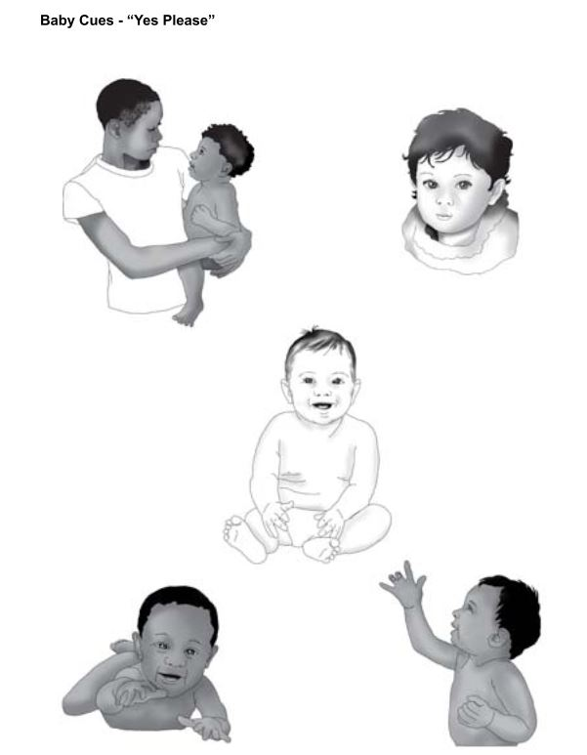
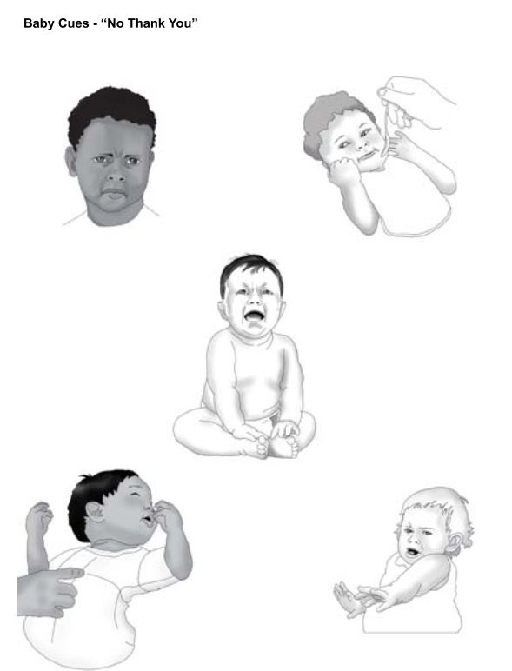

Say: Look at the cards and decide as a group which pictures show a baby trying to communicate “yes, please” and which pictures show a baby communicating “no, thank you.” Discuss with your group members when you have seen a baby make each of these cues.
Distribute a set of cards to each group. Allow a few minutes for discussing the cards in small groups.
Say: Group 1, tell us about one card that you thought was saying “no, thank you.”
Listen to their response.
- Ask: Who else thought that cue meant “no, thank you”?
Affirm their responses. If there is a disagreement, ask the following question.
- Ask: What are some reasons this is “yes”? What are some reasons this may mean “no”?
Continue asking for examples of “yes” or “no” cues until each group has provided ONE example of EITHER a “no, thank you” or a “yes, please” cue and all the cards have been discussed.
Say: The baby cues in the cards are common cues that all babies use, but there are also many other cues. You’ll learn each baby’s cues by paying attention and offering different things—food, sleep, play or affection—until you discover what she wants. Eventually, you will understand your baby’s unique cues and be able to satisfy the baby before the baby uses her strongest cue—crying. When babies start crying, they may not calm down right away even when you are satisfying their need. Practice patience.

Practice the New Content
Say: I’ll visit each group and give you a situation. Decide if the baby will communicate “yes” or “no” in this situation and prepare to demonstrate this cue to the rest of us.
One person in your group plays the role of the baby and another plays the role of the caregiver. If you need more people for your situation, then other group members can play those roles. Your demonstration of the cue should only take a few minutes.
Circulate to every group to give them each a situation listed in the box below. Once every group has a situation, revisit each group to make sure that they chose a cue, decided who would be the baby and the caregiver, and are practicing performing their situation.
Invite a group to perform their situation. Before they begin . . .
Situations:
The caregivers near the baby are yelling at each other in loud angry voices and the baby can hear them.
The caregiver is giving the baby a nice warm bath.
The baby has been left to sit for a long time in a crib and is very lonely and sad.
The mother is eating and the baby wants some food too.
The baby’s tummy hurts and the mother is busy and doesn’t notice.
The caregiver and the baby are playing together and the baby is very happy.
Say: Watch the play and try to recognize the cue and whether it is saying “yes” or “no.” Also notice how the caregiver responded.
At the end of the play, ask the following questions.
- Ask: What was the baby cue?
- Ask: Was it a “yes, please” or “no, thank you” cue?
- Ask: What did the baby want or not want to happen?
- Ask: What did the caregiver do to show love and caring?
Repeat with the rest of the groups and situations. When all are finished, affirm their efforts and help the participants summarize by asking the following questions.
- Ask: Think about all the plays you saw. What were some of the situations that caused the babies to send the caregivers a cue?
- Ask: What are other examples of situations when babies communicate “no” or “yes” that weren’t demonstrated in the plays?

Apply the New Content at Home
- Ask: Now that you have a better understanding of baby cues and how to respond, what will you begin to do or start doing differently?
Affirm their ideas.
Say: Let’s revisit the true/false question. Think about what you learned today and listen to it again. Cover your eyes with one hand and raise your other hand if you think the statement is true.
True or false: Before a child speaks, the only way the child communicates is by crying.
Count the number of raised hands and record the number in the “After Session” column of the True/False Survey. Record the total number of participants in today’s session in the “Number of Participants (Originally)” column.
Say: Thank you for your participation today. I hope you enjoyed the session. Let’s sing the “Four Pathways” song to encourage us until our next session.
Be sure to write down the number of participants in the appropriate cell of the True/False Survey.

Session #3: Language Development
Objectives. By the end of the session, participants will have:
- Described what they remember and have applied from the session on Baby Cues
- Recalled their children’s first words
- Identified how parent/child interaction helps language development
- Memorized the “Four Rules for Language Learning” song
- Practiced encouraging their children’s language development during everyday activities
- Identified opportunities for speaking to children in their care

Materials:
- True/False Survey, which you used in previous session
- Ball of yarn or string
- Five everyday items or pictures of everyday items such as a fruit, vegetable, utensil or item of baby clothing, each placed in a separate bag (four items for the teams and one for the example).
- Language Scenario cards
- The “Four Rules for Language Learning” song (lyrics and melody from the TOT)

Time: 60 minutes

Welcome and Review
Say: In our second session, we discussed baby cues.
- Ask: What have you learned about your own baby’s cues since our session? Share with us what you do when you see and hear these cues.
Affirm their efforts, answer questions and correct any misinformation that could harm the children in their care.
Say: Before we begin today’s session, let’s sing the “Four Pathways” song to remind ourselves of the pathways and to introduce any new members to the ideas in the song.
Sing the song.
Say: In this session, we are going to talk about how to develop the language pathways in your child’s brain.
Listen to the true/false question for this session. Cover your eyes with one hand and raise your other hand if you think the statement is true.
True or false: If you talk to children regularly before the age of 1, they will know more words, find it easier to learn to read and do better in school.
Count the number of raised hands. Record it in the “Before Session” column in the True/False Survey (found at the end of this session).
- Ask: What were some of your children’s first words?
Listen, summarize their answers and thank them for sharing.
Say: Your children’s brains were developing the ability to say these words a long time before they said them. Your children also understood what you were saying to them before they could talk.
In today’s session, we are going to learn about why it is true that talking to babies strengthens their brains and makes it easier for them to read, learn and do better in school.

Introduce the New Content
Say: Let’s begin with how babies learn to speak.
Ask for three volunteers. Seat them so they can catch and throw a ball of yarn with you without dropping it. Make sure there is also enough space between each volunteer so that the other participants can see who is catching the ball of yarn.
Say to the volunteers: Each of you is one of my babies. I will say a word and throw the ball of yarn to one of you. When you catch the ball, repeat the word, hold onto a string of yarn and throw the ball back to me. When we are finished, we will count how many strings of yarn are between each of us.
Throw the ball of yarn to one volunteer five times. Each time, say “baba.” The volunteer will catch the ball, say “baba” and throw it back to you. When you catch it, say “yes, baba,” praise her for trying to speak, and say nice things about how she made her sound (your intention is to use more words overall with the baby).
Throw the ball of yarn to the second volunteer three times. Each time, say “baba.” The volunteer will catch the ball, say “baba” and throw it back to you. When you catch it, say “yes, baba” but don’t praise the volunteer or say anything else.
Throw the ball of yarn to the third volunteer one time. Say “baba.” The volunteer will catch the ball, say “baba” and throw it back to you. Catch the ball of yarn but don’t say anything.
(Note to Facilitator: You can throw the ball of yarn randomly. Just ensure that you throw it to each volunteer for the required number of times).
When you are finished catching and throwing, ask the following question.
- Ask: How many strings are between me and each of the babies?
After the strings are counted, ask the following question.
- Ask: Which one of these babies will have a stronger brain and probably do better in school? Why?
Listen to the responses and add the following points if they aren’t mentioned by the participants:
- The baby with the most strings is having more back-and-forth communication with the caregiver.
- You repeated the baby’s words.
- You used new words as well as repeating the baby’s words.
- You spoke in a loving and caring way which will encourage her to keep making sounds which will eventually become words.
- The baby will hear more words and understand more words.
- Since she knows more words, it will be easier for this baby to learn to read and to do better in school.
- (Note to Facilitator: The baby with the most strings may eventually hear 30 million more words by the time she is 3 than the baby with the fewest strings by the time she is 3 years old (Hart & Risley, 1995).

Say: The yarn exercise shows how the language pathways develop in a baby’s brain. You talk to your baby even before she is able to make sounds. When your baby starts to make sounds, you repeat her sounds and say more words back to her. You speak in a caring way. When babies hear the same sounds and words over and over again, they begin to recognize the words although they can’t speak them yet.
- Ask: What are some things you say to the babies in your care?
- Ask: What are some songs or stories you tell to babies in your care?
Summarize some of the things they say to their babies and praise them for talking to their babies.

Practice the New Content
Say: In the beginning, it can feel uncomfortable talking to babies or very young children who can only make sounds or a few words. Some caregivers aren’t sure what to talk about with babies. In this activity, we’ll practice ways to talk to babies.
Divide the participants into teams of four people.
Say: I’m going to give each team a bag with something in it. Everyone on your team should look in the bag but don’t show it to anyone else in the room. Each person on your team will tell us one thing about what is in the bag without naming what it is. After we have heard four clues about the item in the bag, the rest of us will guess what it is.
Demonstrate the game for the participants to ensure that they understand how to play. For example, give yourself a bag containing a banana and say four descriptive things about it: “This is something that is hard on the outside and soft on the inside, it grows in a tree, it is yellow and you eat it.” Invite guesses only after you give all four clues.
Distribute one bag to each team. Begin the game. After each group takes a turn, ask the following question.
- Ask: What were some of the clues that helped you guess what was in the bag?
Say: Let’s talk about the clues you mentioned (summarize the participants clues—e.g. color, feel, shape, size and what you do with it). You can describe your daily activities to your babies in the same way. For example, imagine I’m feeding my baby.
Pretend to feed a baby.
- Ask: What are some of the things I can talk to her about as I feed her?
If the participants can’t think of ideas, prompt them with questions such as the following: What can I tell her about the food? What can I say about the color, shape, taste, texture of the food? Is it the baby’s favorite food? Where did you get the food?
Also pretend that the baby is making sounds and you are repeating them back to her and praising her.
Say: You can also sing to her or tell her a story as you feed her.
- Ask: What is a song I could sing to her? What is a story or rhyme I could tell her? What is a prayer I can say?
Invite one participant to sing a verse of a suggested song.
Say: It’s your turn to demonstrate how to talk to babies and very young children. I will give each group an everyday situation. Show us what you would do in this situation to encourage a child’s language skills. You can explain what you are doing to the child, sing a song or tell a story. You decide.
Divide participants into new groups or keep the same ones. Assign each group a scenario. See possible scenarios in the box below. Choose the scenarios that are most relevant for the group or create your own. Remember that the point is for the caregiver to be interacting; what she says doesn’t have to be specific to the situation.
Possible scenarios. (Make into cards. Need 2 sets of each scenario.)
Scenario #1: It is mealtime. A baby is eating mashed food with his hands. What can you say to him, sing to him or tell him as he is feeding himself?
Scenario #2: You are putting a child to bed. He can walk by himself and is able to name things. What can you say to him, sing to him or tell him as you help him to get ready for bed?
Scenario #3: You are at the market with a child. She is able to point to things and make sounds. What can you say to her, sing to her or tell her as you do your shopping?
Scenario #4: You are tidying the house with a baby in the room. What can you say to her, sing to her or tell her while you tidy?
Scenario #5: You are putting clean clothes on a baby. What can you say to her, sing to her or tell her as you dress her?
Scenario #6: You are visiting the clinic with a child. She is able to ask, “What this?” and point to things in the clinic. What can you talk to her about as you wait for the doctor?
Scenario #7: Your baby is crying. What can you say to him, sing to him or tell him to help soothe him?

Distribute a Language Scenario card to each small group. Circulate to each group as they prepare their demonstration. Ask each group to perform their demonstration for the large group. At the end of each demonstration, praise the group’s efforts and ask the observers the following question.
- Ask: What are some other things you can say in this situation?
Affirm participants’ ideas.
Say: Remembering four simple rules will help you to develop a child’s language skills.
Listen to this song (or poem) and try to hear the four rules.
Sing the song (or recite the poem) that you prepared on your own or during a training of trainers.
Prepare the song lyrics and melody before this session, making sure the lyrics express the following ideas:
- Talk to your children even if you don’t think they can understand your words.
- Back and forth. If your child says one word or just makes a sound, repeat it to him. This is how he learns to make words and to talk.
- Encourage. When your child communicates with you, respond with words and actions that encourage him and show you care.
- Reading, singing or praying with your baby helps her to learn language.
“Four Rules for Language Learning” song ______________________________________________________________________________________________________________________________________________________________________________________________________________________________________________________________________________________________________________________________________________________________________________________________________________________________________________________________________________________________________________________________________________________________________________________________________________________________________________________________________________________________

- Ask: What are the four rules you heard in this song?
Listen to their answers and confirm the correct responses.

Apply the New Content at Home
- Ask: When are good times during the day to communicate with the children in your care?
If participants say “all the time,” ask for specific examples of activities during the day when they will communicate with the children in their care.
Affirm their intentions and provide additional suggestions if it will be helpful.
Say: Let’s revisit our true/false question. Cover your eyes again with one hand and listen to this statement. If you think it is true, raise your other hand.
True or false: If you talk to children regularly before the age of 1, they will know more words, find it easier to learn to read and do better in school.
Count the number of raised hands and record the number in the “After Session” column of the True/False Survey. Record the total number of participants in today’s session in the “Number of Participants (Originally)” column.
Say: Let’s close the session by singing the “Four Rules for Language Learning” song once more together.
Affirm the participants’ efforts and say goodbye.
.

Session #4: Social and Emotional Development
Objectives: By the end of the session, participants will have:
- Recalled the four major learning paths by singing the “Four Pathways” song
- Compared pictures of two babies and explained possible reasons for these differences
- Demonstrated actions that show love and caring for a baby or child
- Remembered examples of behaviors that are barriers to brain development
- Decided how to show love and caring with the children in their care
- Reviewed key lessons from Sessions #1 through #4

Materials:
- True/False Survey, which you used in previous session
- Picture of learning paths, which you used in Session #1
- Five copies of pictures of healthy and malnourished babies (one copy per small group)
- One set of Situation Cards with situations and options for responding (one card per group)
- Sticks, pencils, straws or dry spaghetti

Time: 50 minutes

Welcome and Review
Say: Welcome to the fourth session. Today, we are going to explore Social and Emotional development, another learning path. Let’s start with singing the “Four Pathways” song to remind us of how children develop bigger, stronger brains.
After participants sing the song, praise their effort.
Say: First, cover your eyes with one hand and listen to this statement. If you think it is true, raise your other hand.
True or false: If you consistently treat babies with love and care, then their brains and bodies become bigger and stronger.
Count the number of raised hands. Record it in the “Before Session” column in the True/False Survey (found at the end of this session).
- Ask: How many of you know someone who isn’t kind to others or isn’t able to control their anger?
After listening to responses, show the picture of learning paths.
Say: Today, we are going to learn more about the learning path that helps children to become adults who are able to manage their emotions; to be kind, cooperate with others, trust others, calm themselves and believe in themselves. This pathway is called the social and emotional pathway.
First, let’s begin with a story of two babies.
Divide the participants into small groups and give each group a copy of the picture of one healthy and one malnourished baby (alternatively, hold up a large picture for everyone to see or pass around). In the picture, the malnourished baby is thin and underweight and looks unresponsive. The healthy baby is bigger and fatter and looks responsive.
Say: This is David and this is Jean Francois. (Note to Facilitator: Change names as needed to reflect common names in your community.) With a partner, discuss:
- What are the differences between David and Jean Francois?
- What might be the causes of these differences?
After a few minutes, ask one pair to state one difference. Ask another pair for another difference. When all the differences are mentioned, ask another pair what they decided might be causing the differences. When the participants have nothing left to say, explain the reason for the differences.
Say: Both babies are eating the same food, they are kept clean and neither of them have a disease. But, David’s caregiver pays attention to his cues, needs and feelings and responds in a loving and caring way. So, David feels connected to his caregiver, trusting her to feed him when he is hungry and stop feeding him if he doesn’t want to eat more.
Jean Francois’s caregiver, however, doesn’t feed him when he is hungry and sometimes continues to feed him even if he doesn’t want to eat more. When she does respond, it isn’t in a loving and caring way. As a result, Jean Francois doesn’t feel connected to his caregiver.
So, even though Jean Francois is being fed enough and is kept clean and free of diseases, the lack of a caring connection is causing his growth to slow. If the caregiver continues to ignore his cues and not respond to them with love and caring, Jean Francois could get sick and die. Even if baby Jean Francois grows to be an adult, he will find it more difficult than baby David to develop self-confidence, trust others and form loving relationships with others, because he wasn’t given a chance to develop a connection based on love and caring with his caregiver.
- Ask: What are your thoughts about this story?
- Ask: What are some things that you do now to help the children in your care feel connected to you?
Summarize their answers.
Say: Those are all good suggestions. Let’s practice some more examples of showing love and caring.

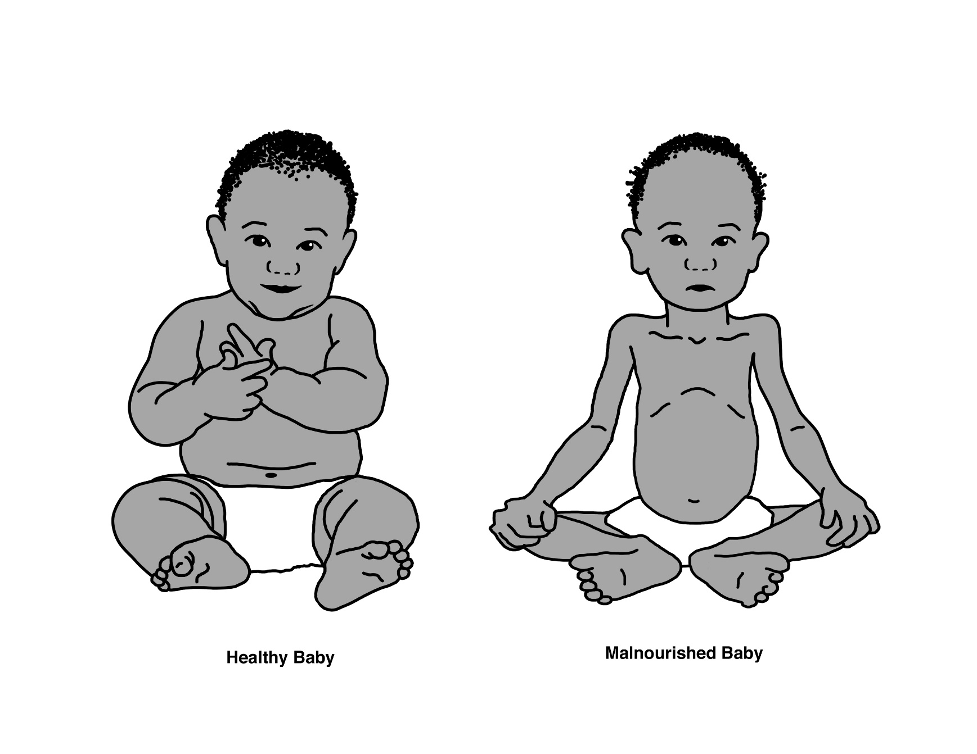

Practice the New Content
Ask for a volunteer. Whisper to the volunteer that you are playing the role of the mother and she is the 9-month-old daughter. Tell her to begin to cry when you walk away from her.
Say: I am the mother and this is my 9-month-old. I am putting her down to do my work.
Walk away from the volunteer, prompting the volunteer to cry.
Say: Every time I put her down she begins to cry.
- Ask: Has this happened to you? Why is she crying? How is my baby feeling?
Listen to their answers and summarize them.
- Ask: How can I show her love and caring right now?
Listen to their answers and act them out.
- Ask: Which suggestions showed love and caring?
(Note to Facilitator: If the participants can’t think of any ways to show love and caring, demonstrate any of the following: pick her up, hold her, rock her, talk to her and tell her what you are doing, or tell her you are close by and will pick her up soon, make eye contact and smile.)
- Ask: What questions do you have so far?
Respond to any questions.
Say: It can be challenging to know what a young child is feeling because they don’t have enough words to express themselves. Let’s do more practice-responding to our children in safe and caring ways in different everyday situations.
Divide the participants into groups of four people. Make sure that there is someone in each group who can read. Distribute a card with one situation and the options for responding to that situation from those that are listed in the box (one card per group).

Say: Each group has a description of a situation and three different choices of what to do in the situation. Read your situation and choose the option that you think is best for showing a child love and caring. Be prepared to show it to us.
Situations (one situation per card).
Group 1: Your 3-month-old baby wakes up from a nap crying. You:
- Ignore him until he stops crying.
- Tell him, “Stop crying or I won’t pick you up.”
- Smile, pick him up and talk softly to him.
Group 2: You are cleaning the house and your 7-month-old is rolling on his back making happy noises. You:
- Tell him what you are doing as you clean the house.
- Tell him to be quiet.
- Ignore him.
Group 3: A visitor comes to see you, and your 1.5-year-old acts afraid of the visitor (whom the child doesn’t know) and tries to hide behind you. You:
  - Push him toward the stranger, scold him and force him to say “Hi.”
  - Pick him up and say, “It’s okay, I am here. You stay close to me and listen while I speak with my friend.”
  - Say, “If you won’t say hello, I’ll put you somewhere far away from me.”
Group #4: Your 1-year-old is starting to walk. Now, she is reaching for and throwing things. You:
- Slap her hand and tell her to stop it.
- Put her in her crib to keep her away from everything.
- Move her elsewhere and give her something else to do or play with.
Group #5: Your 1.5-year-old wants something and can’t have it so he throws himself on the floor screaming and crying. You:
- Yell at him to be quiet and stop misbehaving.
- Hit him until he behaves.
- Say, “I see you are very mad” and try to cuddle him as you show him something else to play with.
Group #6: Your 3-year-old gives a hug to someone who hurt herself. You:
- Praise him for being kind to others.
- Say nothing to him.
- Tell him he is like a girl, too soft.
Circulate among the groups to be sure that they understand the task. Encourage them to practice their demonstrations in their small group.
Begin the demonstrations. After each group’s demonstration, ask the following question.
- Ask: How did the caregiver show love and caring in this situation?
After all demonstrations are completed, ask the following question.
- Ask: What questions do you have?
Respond to any questions.
Show the picture of learning paths again. Place your hand over part of the social/emotional pathway.
Say: My hand represents a barrier on the path, like a snake, puddle or large rock, that doesn’t allow you to continue. Some of the ways we respond as caregivers can become a barrier to our child’s brain development. Each group had other examples of how to respond which weren’t helpful for your child’s development
- What were some of those examples of unhelpful behaviors that were just discussed?
If this pathway in the brain isn’t allowed to fully develop, the child will become an adult who finds it difficult to manage emotions, share and be kind. It will be hard for the child to cooperate with or trust others, or to calm himself and have confidence.

Apply the New Content at Home
Say: We’ve reached the end of our session on the social and emotional development of a child.
- Ask: What is something from this session that you will do with the children in your care to help them feel connected to you and to experience love and caring?
Probe for specific things they will do—ideally actions you would see if you were there—rather than answers such as “I will be more loving and caring.”
Say: Now that you have more information about the social and emotional pathway, listen to this statement again and vote whether it is true or false. Cover your eyes with one hand and, if you think the statement is true, raise your other hand.
True or false: If you consistently treat babies with love and care, then their brains and bodies become bigger and stronger.
.
Count the number of raised hands and record the number in the “After Session” column of the True/False Survey. Record the total number of participants in today’s session in the “Number of Participants (Originally)” column.
Say: We are halfway through our eight sessions, so this is a good time to review everything we have learned.
Divide the participants into teams of five people. Create the following image on the floor using sticks, pencils, straws or dried spaghetti. If you have time for more than seven questions, you can create another copy of the image and continue the game.
Say: I’m going to ask one team a question. The team will have 30 seconds to answer the question. If they answer correctly, they’ll get one piece from this image. If they can’t answer the question, then the team next to them has a chance to answer correctly. The team with the most pieces at the end of the game wins.
Ask the first review question from the box below. If the team provides one of the correct answers for that question listed in the box, remove one piece from the image and give it to the team. Continue with the rest of the questions.
(Note to Facilitator: The questions and answers are at the end of this session.)
Say: Let’s end the session with our “Four Pathways” song.
Sing the song with the gestures, thank the participants and say goodbye. Be sure to write down the number of participants in the appropriate cell of the True/False Survey.

Review questions | Answers
Before babies can talk, what are some of the things they can communicate to you? | “No, thank you”; “Yes, please”; All of their feelings: happy, sad, frustrated and more.
Show us an example of a baby cue and tell us when you have seen a baby use this cue. | Any of the baby cues from Session #2 are correct.
If a baby says “ba, ba” to you, what should you do? | Any of the following are correct: say “ba, ba” back to the baby; praise him for trying to speak; speak some more to him.
What is something you can do to help your baby have a bigger, stronger brain? | Any of the following are correct: speak to him, show love and caring; play with him; sing to him, respond to his cues (all interactions suggested by the participants will help build brain development).
Your friend’s baby wakes up from a nap crying. Your friend ignores him to teach him to stop crying. What should she do instead? | Any of the following are correct: smile; pick him up; talk to him in a soothing voice.
What can happen to a baby if you don’t respond to him consistently with love and caring when he gives you baby cues? | Any of the following are correct: he won’t grow and could eventually die; his brain won’t be big and strong; he won’t have self-confidence; he’ll have trouble cooperating; he’ll have trouble controlling his emotions; he’ll have trouble showing kindness and caring, and trusting others.
Why is it good to sing to your baby? | Any of the following are correct: she will have a bigger, stronger brain; it helps her to develop her language skills (it helps her learn how to speak); it shows her love and caring.

Review questions | Answers
You are feeding your baby a banana. What are two things you can say to her while you are feeding her? | All answers are correct.
Sing the “Four Pathways” song. | If participants can sing at least half the song, it’s correct.
What is one thing you can do to prepare your child to be a good reader and a good learner? | Any of the following are correct: talk to her; sing to her; interact with her; name things for her; read to her.
Why is watching TV not a good way to develop a child’s learning path for language? | Because the child cannot interact with the TV.
You are giving your child a bath. What are two things you can say to her while you are bathing her? | All answers are correct.
Show us another example of a baby cue and tell us when you have seen a baby use this cue. | Guess what cue they are demonstrating. Discuss when participants have seen this cue and ask if it looked like the demonstration, or ask participants to demonstrate other ways it looked.
Sing a song that you can sing to a baby or small child. | Any answer is correct.

Session #5: Physical Development
Objectives. By the end of the session, participants will have:
- Described how they are applying their new knowledge and skills with children in their care
- Recognized types of activities that are appropriate for different age groups
- Sequenced pictures to depict the stages of physical development
- Identified ways to support children’s physical development using everyday objects

Materials:
- Picture of learning paths, which you used in Sessions #1 and #4
- True/False Survey, which you used in previous session
- Prepare a quick, less-than-5-minute physical game that is appropriate for children under 3 years old and that all the participants can play
- Two sets of physical development picture cards (one set per group)
- Everyday objects such as a bowl, a spoon, a cloth, some cups, rice,
fruits, a soccer ball, a steady chair or a small stool
- Two balls (or any two items that can be easily passed around)

Time: 60 minutes

Welcome and Review
Say: Welcome to our fifth session. Before today, we’ve explored understanding and responding to baby cues, talking to your children and showing your children love and caring so they can develop a connection to you.
- Ask: How have you applied what you’ve learned when you are with children? Share one example with us.
Listen to a few examples. Affirm the participants’ efforts and introduce the session. Hold up the picture of learning paths.
- Ask: Which two learning paths have we learned about before today?
Ensure the correct answers are identified: language (which also includes baby cues) and social and emotional development.
Say: Today’s we’ll explore the physical development learning pathway for children from birth to 3 years old. This time there are two true/false questions about this topic. Cover your eyes with one hand and raise your other hand if you think the statement is true.
True or false: When you play games with children, you are developing their body and their brain.
True or false: A child’s everyday actions such as grabbing, holding, pushing, crawling and walking show us that their brain is developing.
Count the number of raised hands. Record it in the “Before Session” column in the True/False Survey (found at the end of this session).
.

Introduction to New Content
Say: Playing with your child is a positive and enjoyable way for them to develop their body. Playing also develops the pathway in the brain that controls movement.
- Ask: What are some ways that you play with children under 3 years old?
After participants provide examples of how they play with young children, lead them through a playful activity that is quick and fun. (Note to Facilitator: Written suggestions are in the box below and illustrations of additional play activities are on the following page. Adapt or replace these as appropriate for your community.)

  - Peek-a-Boo
  - Patty Cake, or other lap game
  - “Little Tea Pot,” or other song with actions
  - Through the Tunnel—stand with legs spread wide, let crawling baby or toddler go through the tunnel
  - In the Fort—put a sheet over a chair or table, let child crawl and play under it
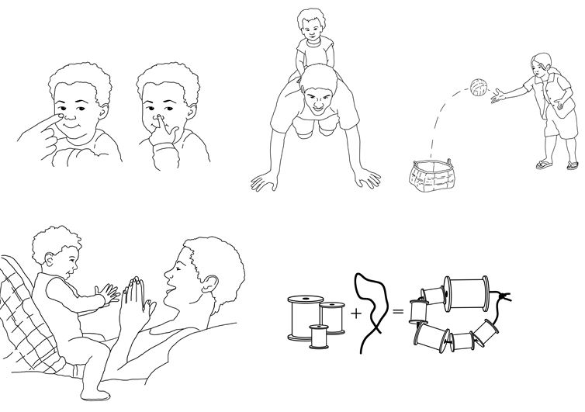

- Ask: What parts of the body did you use as you played? What other physical skills did you use?
Affirm responses and encourage participants to identify all the body parts and skills they used, such as developing coordination (physical), saying new words (language) or smiling, making eye contact and following along (social-emotional).
- Ask: At what age could a child could do this activity? Could a 6-month-old? A 1-year-old? A 2-year-old?
After listening to responses, quickly discuss why different age groups could or couldn’t do this game.
Say: Let’s try some more playful activities and decide which age could do each one.
Lead participants through a clapping game.
- Ask: At what age could a child do this activity? Why or why not?
If participants have trouble answering, help them by asking if a 6-month-old could do this activity? Could a 1-year-old? Could a 2-year-old?
Affirm the participants’ suggestions. If participants suggest anything that is dangerous or age-inappropriate, explain why it is inappropriate and suggest an alternate activity.
Lead participants through the Body Part Game: a caregiver says one body part, touches it and asks the child to find the same body part on her own body (and name the body part if she is learning to speak).
- Ask: At what age could a child could do this activity? Why or why not?
If participants have trouble answering, help them by asking if a 6-month-old could do this activity? Could a 1-year-old? Could a 2-year-old?
Say: It’s important not to force a child to do something that his body is not ready to do. Physical ability develops in a particular order. Let’s look at the order more closely.
Divide the participants into two groups. Distribute a set of physical development picture cards to each group. Give one card to each member of the group.
Say: Hold up your picture so each member of your group can see it. Each card shows a different physical action. Without talking, order yourself in a line to show the simplest activity to the most difficult. When you are done, the first person in your line should be holding the card for the simplest action and the last person in your line should be holding the card with the most difficult action.
Check the results. If any of the pictures are out of order, ask the participants questions to help them reconsider the placement of the pictures. After confirming the correct order of all the cards, ask the following question.
- Ask: What cards/actions were the most confusing to you?
Listen to a few responses.
Say: Not every child reaches the same stage at exactly the same time. For example, some children are walking by the time they are 1 year old, while others may not walk until many months later. That is not a problem. If your baby cannot walk by 18 months, you should see a doctor and have her development checked.

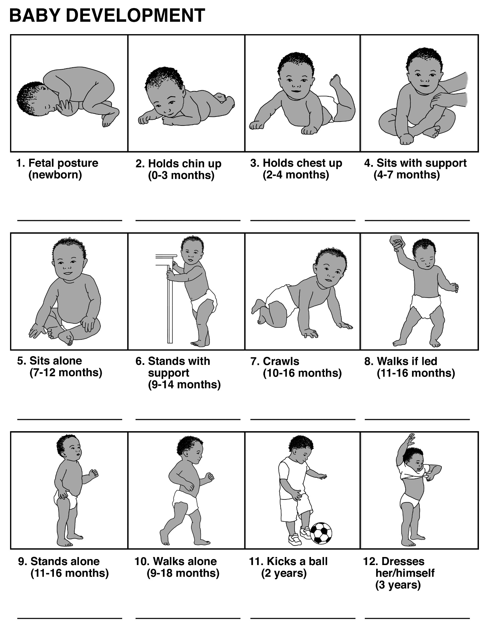
- Ask: What cards/actions were the most confusing to you?
Listen to a few responses.
Say: Not every child reaches the same stage at exactly the same time. For example, some children are walking by the time they are a year old while others may not walk until many months later. That is not a problem. If your baby cannot walk by 18 months, you should see a doctor and have her development checked.

Practice the New Content
Say: Now that we’ve put the actions in order, let’s remember what else children can do with their bodies at different stages.
For example, let’s look at the card of a child who is less than 1 month old.
Show the card to the group.
- Ask: What is this baby able to do with his body? If participants need help answering this question, ask additional questions such as: Can she move her eyes? Mouth? Head? Arms? Legs? Sit up alone? Grab things with her hands?
Listen to their suggestions and affirm the accurate answers.
Say: Here is what I can do during my daily activities to help her use her physical skills from when she is a newborn to about 4 months old.
Demonstrate these actions as you describe them.
Say: When she is a newborn…
- I can make sure she has a comfortable place for sleeping because she can’t move on her own or sit up yet.
- I must hold her head and neck when I pick her up until she is strong enough to do it on her own.
- When I am holding her, I can make facial expressions because her eyes are learning to focus and she will love to mimic the faces I make.
When she begins to hold her chin up I can…
- Give her time on her tummy. When she is placed on her belly, she will naturally want to push herself up and look around. Some time on her belly every day will help her develop her strength.
When she is around 3 months and begins to hold her chest up I can…
- Hold something up in front of her to try to look at.
- While above her, talk to her and tell her a story and she will want to look up to see me while she listens.
We’ve practiced ways to play with children under 3 months old.
Let’s play a quick game to share ideas on simple ways to help your children between 4 months and 3 years old develop the learning path for physical movement in the brain.
Place the participants in a circle. In the middle of the circle, have household items such as a bowl, a spoon, a cloth, some cups, rice, fruit, a soccer ball, a steady chair and a small stool.
Show the participants two balls (or any items that can be easily passed around) and explain the game.
Say: We are going to pick a happy, lively song that we can all sing, and I’ll pass around two balls (or other items) in opposite directions. Pass them as quickly as possible. When I say STOP, I will ask the person holding one of the balls to answer a question. The items on the floor may help you to think of answers. If the person has trouble answering, she can ask the person holding the other ball to help.
Have the group pick a song and begin the game. Pass one ball clockwise and the other counter clockwise. Sing the song. Say STOP and ask a person holding one ball to answer a question. See the following box for suggested questions. Ask the person holding the other ball to help, if needed. Confirm or correct their responses using the possible answers listed in the box, though other answers may also be correct.
Do one practice round, so everyone understands the game.
Questions | Possible answers
Your child is learning to pick things up with his index finger and thumb. Which of the items on the floor, or elsewhere, can he practice picking up?  (9 months) | Spoon, cup, cloth, pen, paper, mobile phone, biscuit
Your child can climb on things. How can he practice without hurting himself?  (3 years) | Small stool, chair or bed
Your child is learning to stack things on top of each other. Which items on the floor, or in your home, can you use to help her practice stacking?  (18 months) | Cups, bowls, blocks, boxes
Your child is able to bring the food in his hand to his mouth. What objects will help him to practice?  (7 months) | Cooked rice, biscuit, fruit
Your child is learning to crawl. How can you help her practice?  (9 months) | Ask her to crawl toward you.
You child is able to pull herself up to a standing position. How can you help her practice?  (10 months) | Stool (must be steady). Let her hold onto you.
Your child tries to reach for things now. Which items on the floor could help him practice reaching?  (7 months) | Any of the smaller items.
Your child can walk holding onto furniture. How can you help her practice?  (1 year) | Name places with furniture that she can use.
Your child can throw things. Which of these things will she try to throw?  (2 years) | Anything that is light enough for her to pick up.
Your child can climb steps one foot at a time. She can also throw overhand and run. Where can she practice these skills?  (3 years) | Name safe places in the area.

Apply the New Content at Home
Say: Let’s work in pairs. Discuss how you will use today’s information with the children in your care.
- Ask: Remember the picture cards? What actions are your babies and small children able to do now?
Affirm their suggestions.
Say: Remember that children don’t all develop at exactly the same time. Forcing your child to do things before she is ready won’t make her learn it faster. For example, forcing her to walk won’t make her be able to walk. She’ll walk when her brain is prepared for it and her body is strong enough to do it.
It is important to give your children encouragement, space to move around and objects to play with. They will learn to use their bodies. If your child seems to be many months behind other children, talk to your doctor.
We’ll end the session with the same true/false statements.
True or false: When you play games with children, you are developing their bodies and their brains.
True or false: A child’s everyday actions such as grabbing, holding, pushing, crawling and walking show us that his or her brain is developing.
Count the number of raised hands and record the number in the “After Session” column of the True/False Survey. Record the total number of participants in today’s session in the “Number of Participants (Originally)” column.
Say: Let’s end our session with the “Four Pathways” song.
Sing the song with gestures, thank everyone for their participation and end the session. Be sure to write down the number of participants in the appropriate cell of the True/False Survey.

Session #6: Developing the Thinking Pathways
Objectives. By the end of the session, participants will have:
- Recognized that children and adults perceive things differently
- Identified at least five ways that children develop their thinking skills
- Suggested how to encourage a child’s thinking skills during an everyday task
Materials:
- True/False Survey, which you used in previous session
- Picture of an elephant
- Flavored candy or bite-sized pieces of fruit or vegetables, some of which are hard and others soft (one piece per participant)
- A small amount of uncooked rice (or another easily identifiable item) in a bag
- Everyday objects such as a cloth big enough to put over your head, three spoons and three cups

Time: 60 minutes

Welcome and Review
Say: Welcome to the sixth session. We are going to learn about the final learning path. Let’s sing the “Four Pathways” song to remember them and to teach them to any new friends who are joining us today.
Sing the song with the gestures. Affirm participation.
Say: As with every session, we begin with a true/false question. Cover your eyes with one hand and, if you think the statement is true, raise your other hand.
True or false: Children experience the world in the same way adults do.
True or false: Babies develop their thinking skills with their hands and their mouth.
Count the number of raised hands for each question and write the number down in the appropriate cell of the True/False Survey.
Say: By the end of this session, you will know for certain if these statements are true or false.

Introduce the New Content Part I
Say: Today’s session begins with a story about children and an elephant. One day, there was great excitement in the village. The people heard that an elephant was going to visit. They had heard stories about elephants but had never seen a real one. Many parents took their children—some younger than 3 years old—to see the elephant, because it might be their only chance to see one in their lifetime. The people walked and walked, carrying the children in their arms, until there in front of them was the elephant.
Show the picture of the elephant.
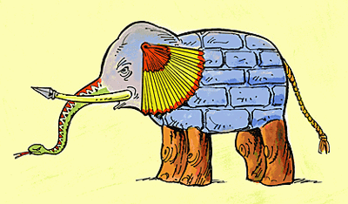
Continue the story, pointing to the different parts of the elephant as you tell the story.
Say: The children were very curious. A mother held her baby close and slowly came toward the elephant. Some of the other children walked around the elephant.
One child reached out and touched the elephant’s leg.
"Oh, an elephant is the same as a tree," she thought as she touched the leg.
"Oh, an elephant is just a rope," thought another whose fingers were grabbing the tail.
The third child ran her hand along the elephant’s trunk. “Oh no,” she said, running to her father, “An elephant is a type of snake.”
The fourth child felt the tip of the elephants tusk and ran toward her mother saying, “An elephant is a spear and can hurt us.”
A mother held her baby close to the elephant. The baby who was still too young to see properly turned her head away from the elephant thinking, “Something near me smells bad, not nice like my mother.”
- Ask: Which child understood what an elephant was?
Summarize their answers.
- Ask: How could each child have a different understanding of the same thing?
Summarize their answers.
Say: This story is a reminder that our children don’t understand or experience the world like we do. We need to be patient with them as they learn, and encourage them so they enjoy learning. In the next activity, we’ll explore some of the ways that children develop their thinking, with learning and problem-solving skills from the time they are born until they are 3 years old.

Introduce New Content Part II
Say: Please close your eyes. I will place something in your hand and you will eat it. It will taste good, don’t worry. Don’t tell us what it is.
Place a flavored candy or bite-sized piece of fruit in each participant’s hand. (Repeat with a harder food, like a carrot, if you wish.)
Say: Now, I’m going to pass around a bag. Don’t look, but feel what is inside the bag. Don’t tell us what it is. Pass the bag to the next person until everyone has felt inside the bag.
Pass around a bag of rice (or some other item that they can identify through touch).
- Ask: What did you put in your mouth? How did you know what it was?
- Ask: What did you feel with your hands? How did you know what it was?
Affirm participants’ responses.
Say: You’ve just experienced how young children develop the thinking path in their brain. They use their mouth, eyes and hands to learn about size, shapes, taste and other characteristics of different items. When you see a child looking, touching and putting things in her mouth, she is trying to learn.
- Ask: What are some things you have seen your small babies try to put in their mouths or touch with their hands?
Listen to and affirm their responses.
Say: It’s normal for babies to want to put things in their mouths, but be careful not to let your baby put small things in her mouth that she could choke on.
Let’s identify other ways that children develop their thinking skills. Remember: thinking involves learning and problem-solving.
Place the following in the middle of the floor: a cloth big enough to put over your head, three spoons and three cups.
Say: Let’s sing a song that everyone knows. While you are singing, I’ll show you some things that babies and children do to develop their thinking skills. Try to remember at least five of my actions.
When the participants begin clapping and singing, do the activities described in the box. Pause between each activity so they can tell when you are stopping one activity and starting the next one.
Activities:
- Put a cloth over one of the participant’s heads. Pull it off and clap and smile in surprise.
- Sit near one of the participants and imitate what she is doing with her body.
- Catch the attention of one of the participants and point to something. Make sure she notices what you are pointing at.
- Put the spoons in the cups.
- Pretend to be looking for something (put a cup under a cloth) and then find it.
- Sort the spoons from the cups.
- Put all the spoons together and all the cups together.
- Build a bridge with something (spoons and cups will work).

After you demonstrate all the activities, ask the following question.
- Ask: What did you see me do?
Listen for the following and add anything they missed: play peek-a-boo, imitate someone, point to something, find something, sort things that are alike, build, stack, put smaller items into larger items, etc.
- Ask: When have you seen any of the children in your care do these types of actions but maybe with different objects?
Listen to and affirm their responses.
Say: These are some ways your children are developing the thinking pathway in their brain. They do these things over and over again because they are making the pathway strong.

Practice the New Content
Say: Now that you’ve seen how a child develops his thinking skills, you can help him in your everyday activities.
Divide the participants into groups.
Say: Think about all the actions you watched me do in the previous activity and pick two of them. Now, imagine you are cooking or preparing food with your child. With your other group members, answer the following question.
- Ask: How can you encourage your child to do these two actions as you are cooking?
Circulate among the groups so you can help them, if necessary, to remember two of the actions you did in the previous activity and to think about how they can encourage a child to do those types of activities as the group members are preparing a meal. When the groups are ready, call them back together.
Say: Please share your two actions with the rest of us.
(Note to Facilitator: See the box for examples. They are not the only possibilities.)
Possible participant actions:
- Describe the size, taste and texture of the food. Let her feel it.
- Give your child cups, bowls or other safe cooking items to stack.
- Encourage your child to imitate what you are doing. Ask her what she is cooking.
- Let your child touch things before you cook with them. Notice how rice feels versus how beans or lentils feel.
- Show your child the different items you use and say the names of those items. Later ask him the names of those items.
- Ask your child to pick up items, give you items, point to items or put similar items together as you cook.

Apply the New Content at Home
Say: We’ve reached the end of our session.
- Ask: What will you do differently at home now that you have an understanding of how children develop the thinking/learning path?
Listen to and affirm the suggestions and wish them luck with their ideas.
Say: Let’s revisit our true/false questions. Cover your eyes with one hand and raise your other hand if you think the statement is true.
True or false: Children experience the world in the same way adults do.
True or false: Babies develop their thinking skills with their hands and their mouths.
Count the number of raised hands and write the number down in the appropriate cell of the True/False Survey.
Say: Thank you for your participation. The children in your care are going to enjoy all the ways you will help them to develop their thinking skills.
Be sure to write down the number of participants in the appropriate cell of the True/False Survey.

Session #7: Baby Massage
Objectives. By the end of the session, participants will have:
- Explained how they are using their new knowledge and skills from Sessions #1– #6 with children in their care
- Described how they feel about being touched
- Recalled what they learned about love and caring in the sessions
- Observed and practiced a baby massage
- Recognized opportunities during a typical day to provide small massages
- Stated when they will perform a massage on their babies at home

Materials:
- True/False Survey, which you used in previous session
- A doll, towel and oil
- Copies of handout showing the massage sequence (one copy per participant)

Time: 60 minutes, or 85 minutes with video

Welcome and Review
Say: Welcome to our seventh session. Before we begin today’s topic, let’s take a few minutes to share our experiences in this workshop.
- Ask: What are you doing with the children in your care to help them grow bigger, stronger brains?
Listen for a sample of answers and encourage their efforts.
Say: Today’s topic is massage. At the beginning of each session, I ask you true/false questions about the topic. Here are today’s questions. Cover your eyes with one hand and raise your other hand if you think the statement is true.
True or false: Massaging a baby is one way of showing love and caring.
True or false: If you talk to a baby during a massage, you are developing both her language skills and physical skills.
Count the number of raised hands. Record it in the “Before Session” column in the True/False Survey (found at the end of this session).
- Ask: How do you feel when someone you love and trust holds your hand, or puts their hand on your hand or arm?
Summarize and affirm their responses.
Say: Babies experience similar feelings when you hold them, snuggle them and rock them. Your touch tells your baby that she is safe, loved and cared for by you.
- Ask: What do you remember from our previous sessions about the importance of feeling loved and cared for?
Summarize and affirm their responses.
Say: In this session, we’ll learn about a pattern of touch called baby massage and how it benefits your baby.
- Ask: Has anyone had a massage?
- Ask: Who hasn’t had a massage?
Wait for participants to raise their hands, as appropriate, to both questions.
Say: Turn to the person next to you and give that person a quick shoulder massage, so people who have never had a massage can have the experience and those who have had one can remember what it feels like.
(Note to Facilitator: You can replace the shoulder massage with a safe, comforting touch on someone’s arm or whatever is culturally appropriate.)
- Ask: How does it feel to be massaged?
Listen to a few responses.
- Ask: What are the four pathways that develop in a baby’s brain?
Listen to their responses and add any missing pathways.
Say: Baby massage has positive effects on all these pathways. It promotes a close and loving relationship between you and the baby. It makes your baby healthier and strengthens his body so it can fight diseases. It can also help him to sleep and poop better.
There are three things to prepare for an enjoyable massage.
- First, create a space where your baby feels safe and secure. Use towels, blankets or your legs to create a soft place for the baby to be nestled. Make sure that the temperature is warm, and try to avoid distractions and loud sounds. Choose an oil to use for the massage. Edible oils are preferred, so using the same oil you cook with is often the best choice.

- Ask: Can you show me a position that you would use to give a baby a massage?
Affirm any of the following answers: kneeling, sitting with legs in a V position, sitting with soles of feet together and the baby nestled inside, sitting cross-legged, or sitting with the baby on outstretched legs.
- Second, prepare yourself. Wash your hands, and be sure your nails are trimmed and you aren’t wearing any jewelry that could scratch the baby.
- Third, choose a good time for a massage. The best time for a massage is when your baby is calm and alert, often either before or after a nap or bath. Be sure to wait about an hour after a meal. When choosing the time for the massage and throughout the massage, pay attention to your baby’s cues—the more you can understand, the more enjoyable the experience will be for both of you.
Demonstrate a baby massage using a doll. Invite the participants to observe you and to copy your actions using their own baby (if the baby is willing) or with someone sitting next to them in the group with whom they can do so comfortably (without using the oil).
Say: To begin, pour a small amount of oil into your hands and rub them together to warm the oil. Make eye contact with your baby, smile and begin by asking your baby for permission: “Would you like a massage?”
LEGS:
- Support the ankle with one hand as the other hand wraps in a C shape around the leg at the hip. Smoothly stroke from the hip to the ankle; switch hands and repeat on the inside of the leg.
While giving massage, use gentle but firm pressure.
- Gently grasp the leg with both hands side by side and gently twist them in opposite directions as your hands glide down the length of the leg from the hip to the foot. Be sure not to twist the knee.

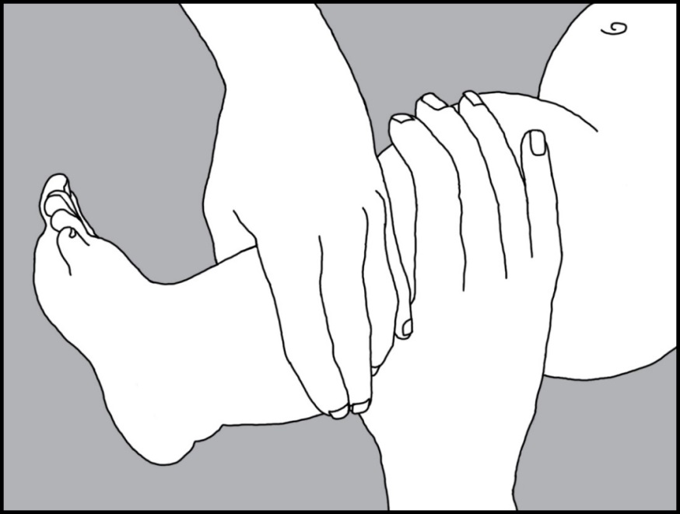

- Gently grasp her legs, bend her knees and press them up toward her tummy. Avoid placing your fingers in the sensitive area behind her knees.
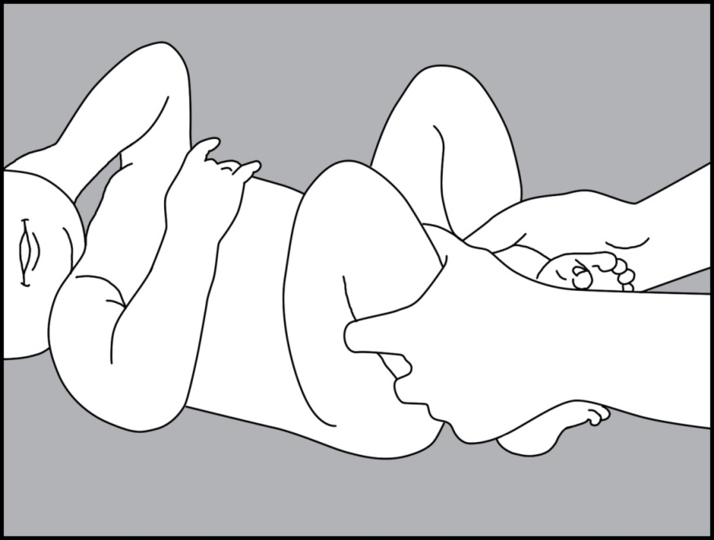
CHEST:
- Gently rest your palms on each side of the sternum with your fingers pointing away from you. This is Chest Rest position. Remember to maintain eye contact and smile; this is special time for you and your baby.
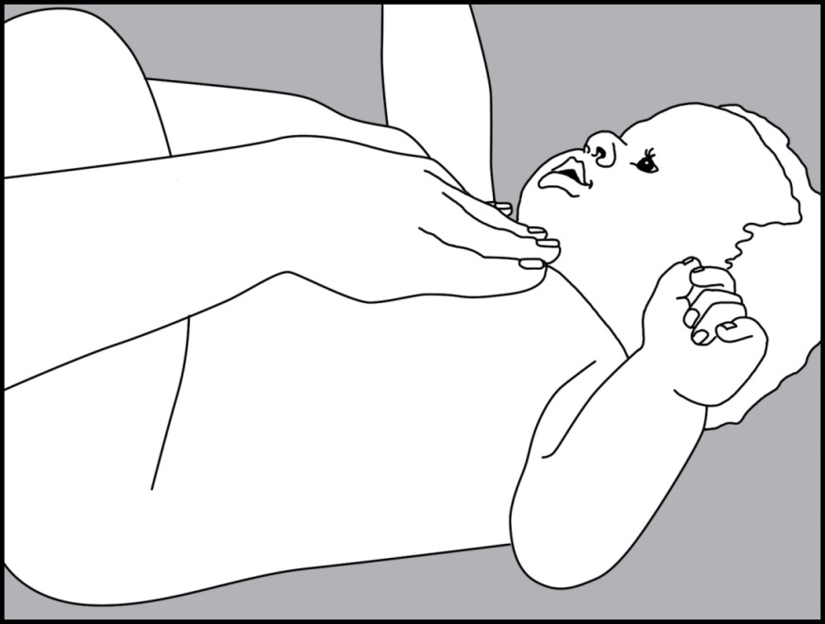
- From the Chest Rest position, slowly glide your hands outward over the chest across the shoulders. The movement is like pressing open the pages of a book.
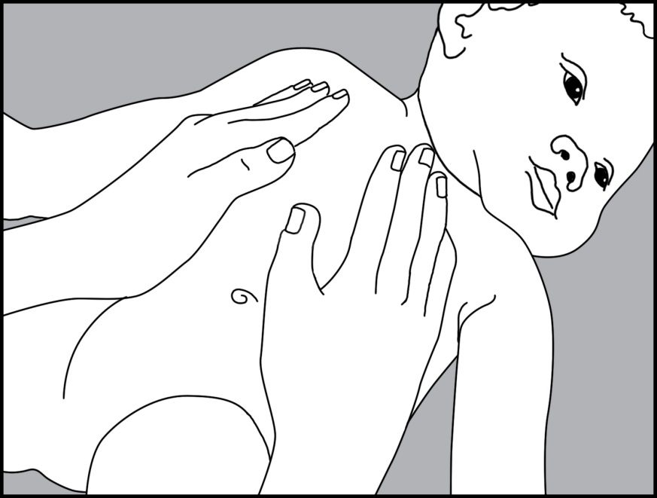
- Place your hand just above your baby’s hip. Glide diagonally across the chest and over the opposite shoulder. As your first hand nears the shoulder, your other hand will begin the same motion, crossing from the hip to the shoulder on the opposite sides. Keep your movements smooth and fluid.
ARMS:
- Grasp the baby’s arm with both hands side by side and gently twist them in opposite directions as your hands glide down the length of the arm from the shoulder to the wrist.
- Support the wrist with one hand as the other hand wraps in a C shape around the arm at the wrist. Smoothly stroke from the wrist to the shoulder, switching hands and moving in a fluid motion.
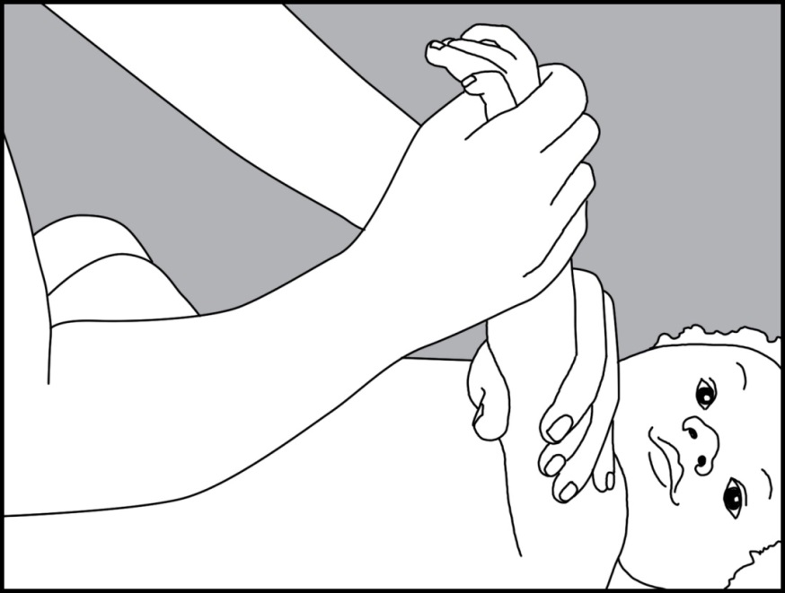

- Ask: What are you enjoying the most so far?
Summarize participants’ responses.
Say: A safe touch and massage feel good, but sometimes babies don’t want to be massaged. Pay attention to your baby’s cues.
- Ask: What is a “no, thank you” cue that a baby might give you when you try to massage him?
Affirm participants’ responses.
Say: It isn’t necessary to do a full massage. You can do small massages during the day to connect with your baby, or to soothe her when she is stressed.
Use the participants to demonstrate any of the examples in the boxes. Choose the examples most relevant and interesting for the group. Do as many as time will allow.
Example 2:
Say: (Participant’s name) is holding her baby on her lap. How can she offer a simple massage for her baby in this position?
Listen for suggestions and add any of the following ideas for hand massage:
- For the Palm Glide, gently glide the side of your finger from the base of the palm to the base of the fingers. Do not pull or twist the baby’s wrist.
- For the Squeeze & Pull, gently roll each finger with your thumb and forefinger and give a tiny tug at the end.
- For the Top of Hand Stroke, support the baby’s hand with yours as you place your thumbs on top of your baby’s hand, gliding your thumbs from the base of the wrist to the base of the fingers.
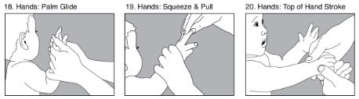
Example 1:
Say: (Participant’s name) is carrying a baby on her back. What is a small massage she can give her baby while the baby is on her back?
Listen for suggestions and add any of the following ideas for foot massage:
- For the Sole Glide, gently glide your thumb or the side of your finger along the sole of the foot from the heel to the toes.
- For the Squeeze & Pull, gently roll each toe with your thumb and forefinger and give a tiny tug at the end.
- For the Thumb Circles, gently make small circles over the top of the foot and ankles with your thumbs or fingers.
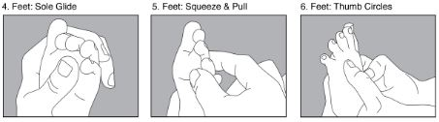

Apply the New Content at Home
Example 3:
Say: If your baby is constipated or has colic or gas, massaging the stomach will help.
However, avoid the belly button area on a newborn if the umbilical cord is still attached or not fully healed. Also, do not apply pressure to the base of the baby’s breast bone.
Demonstrate on a doll or a participant. Encourage participants to follow along by massaging each other if they are comfortable doing so.
- For the Rest motion, gently rest both hands on the tummy and maintain eye contact.
- For the Sweep motion, using the outer edge of the hand closest to you, begin a smooth stroke at the base of the ribs, sweeping toward yourself and ending at the lower abdomen. As that hand leaves the tummy, the other hand begins the same motion.
- For the Tummy Time motion, massage the tummy in a clockwise direction with the pads of your fingers or flat hands, making circles around the belly button and covering the entire abdomen.
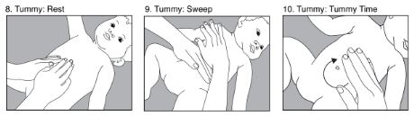

- Ask: When could you try to massage your baby? Which massage will you do?
Affirm participants’ ideas. Thank everyone for their participation.
Say: We will check with you next week to share your stories about giving your baby a massage.
Let’s revisit the true/false questions. Think about what you learned today and listen to them again. Cover your eyes with one hand and raise your other hand if you think the statement is true.
True or false: Massaging a baby is one way of showing love and caring.
True or false: If you talk to a baby during a massage, you are developing both her language skills and physical skills.
Count the number of raised hands and record the number in the “After Session” column of the True/False Survey. Record the total number of participants in today’s session in the “Number of Participants (Originally)” column.
.
Distribute a copy of the massage sequence handout to each participant to take home.
Say: Let’s close with the “Four Pathways” song.
Sing the song with the gestures and thank the participants for their participation.

If participants have questions, see the frequently asked questions and corresponding answers in the box.
Frequently Asked Questions and Answers:
- What oil should I use?
Use any oil you would cook with; if it is safe to eat, it is safe to apply on your baby’s body. Possible options are almond, grapeseed, sesame, coconut, corn, vegetable or olive oil. Do not use mineral oils, oils with fragrances or essential oils.
- When is it safe to give a massage?
If your baby has any serious medical conditions, or she has a fever, rash, bruises or cuts, talk with your primary healthcare provider before you begin massage.
Massage is good to help your baby if she is constipated. But, if your baby has diarrhea, do not massage her stomach.
If your baby has ringworm, it is not safe to give her a massage. Ringworm is a fungal infection, and it typically looks like a circular lesion. Take your baby to see a doctor. It is contagious and is spread by skin-to-skin contact with someone who is infected.

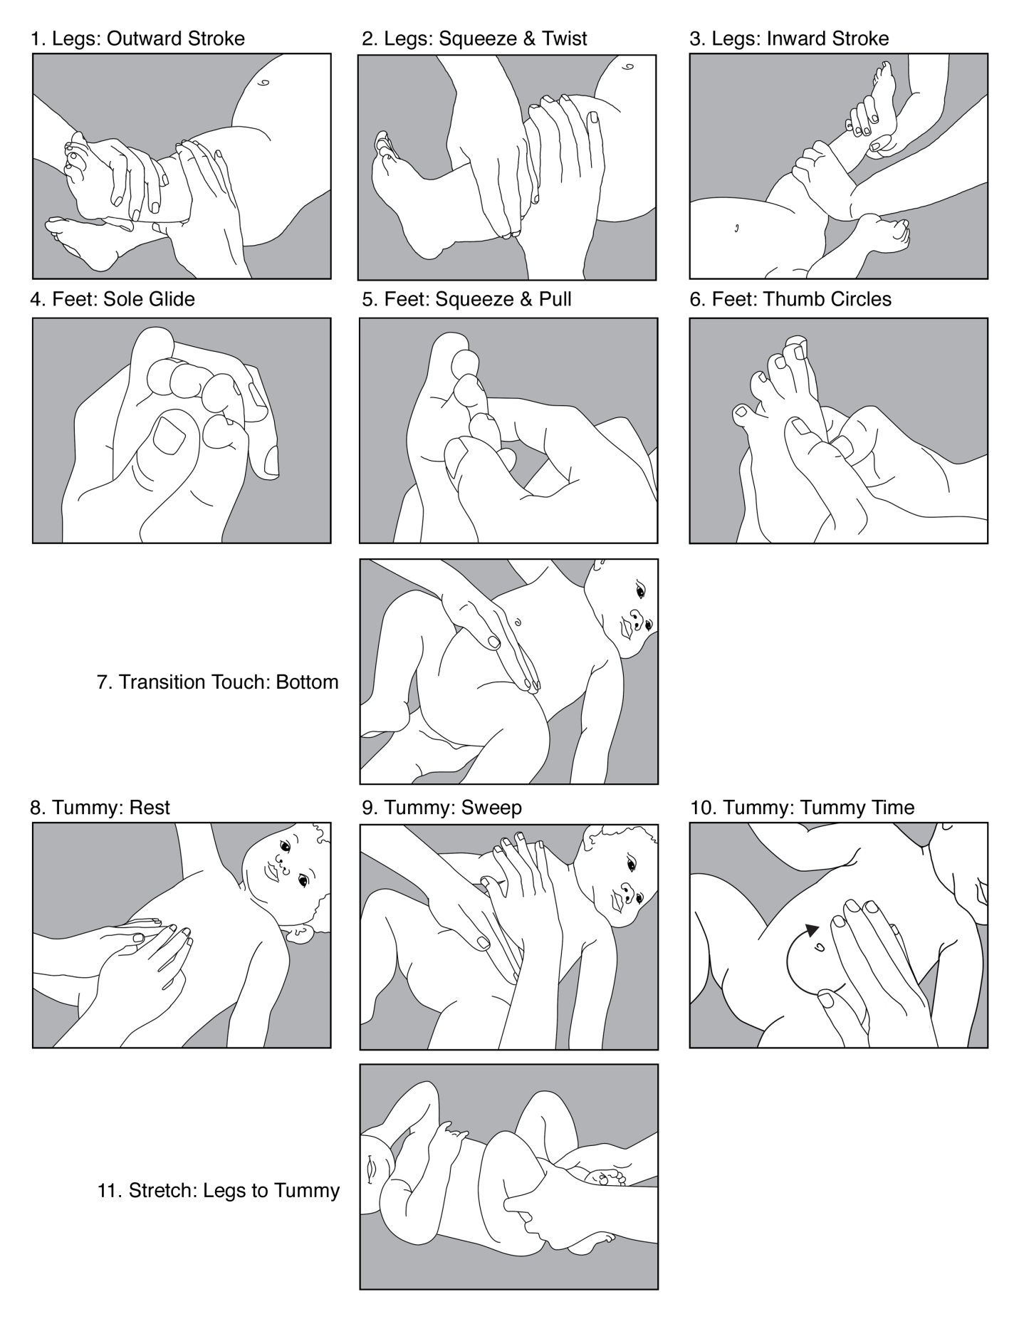

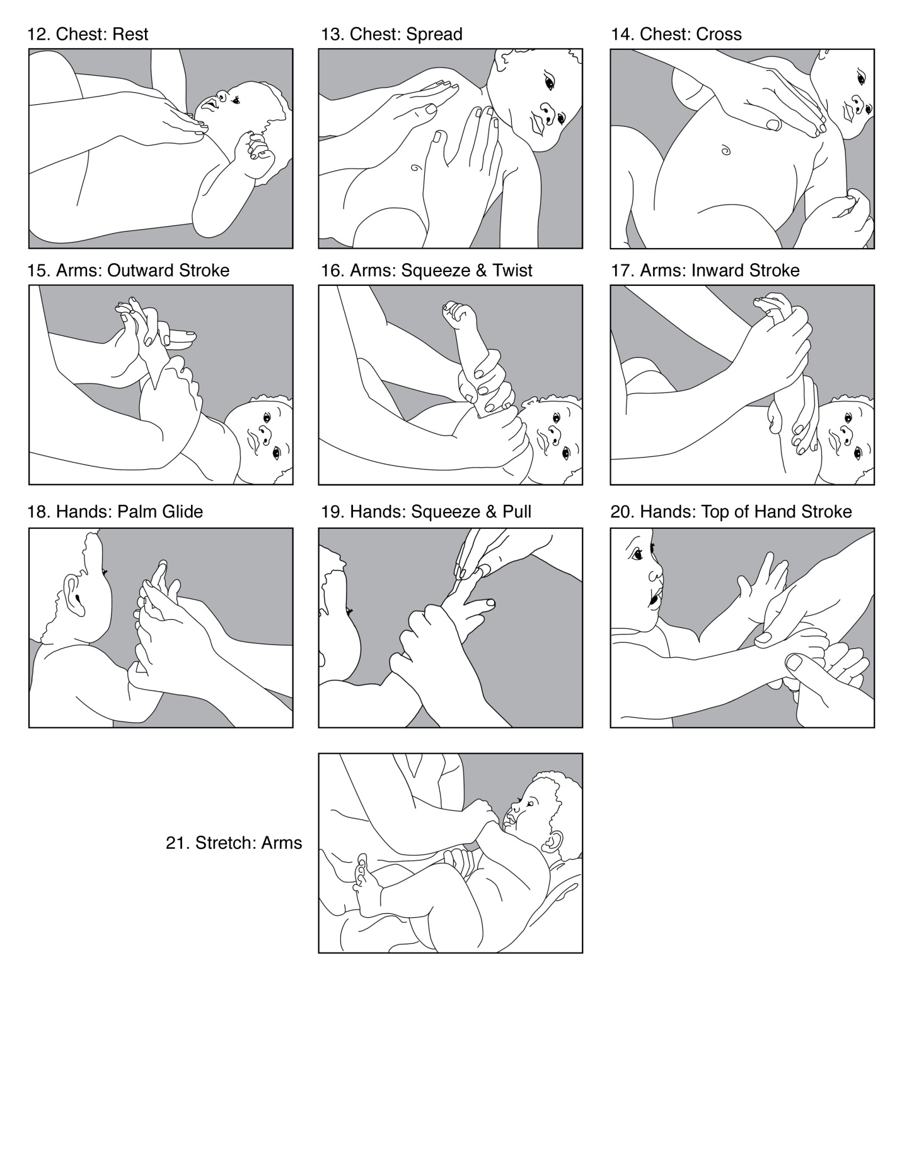

Session #8: Basic Health, Hygiene, Safety and Nutrition
Objectives. By the end of the session, participants will have:
- Clarified best practices associated with immunizations, breastfeeding and nutrition, hygiene, sanitation and safety
- Decided how to adopt these practice in their homes

Materials:
- Picture of healthy and malnourished babies, which you used in Session #4
- True/False Survey, which you used in previous session
- Local immunization card—you will need to find this and bring with you
- Information collected from the nearest health clinic regarding immunizations, breastfeeding, sanitation and safety
- Picture of breastfeeding
- Picture of hand-washing
- Picture of diarrhea transmission

Time: 75 minutes

Welcome and Review
Say: Welcome to our final session. Today, we are going to discuss what we can do in our own homes to help our children stay healthy.
Show picture of healthy and malnourished babies.
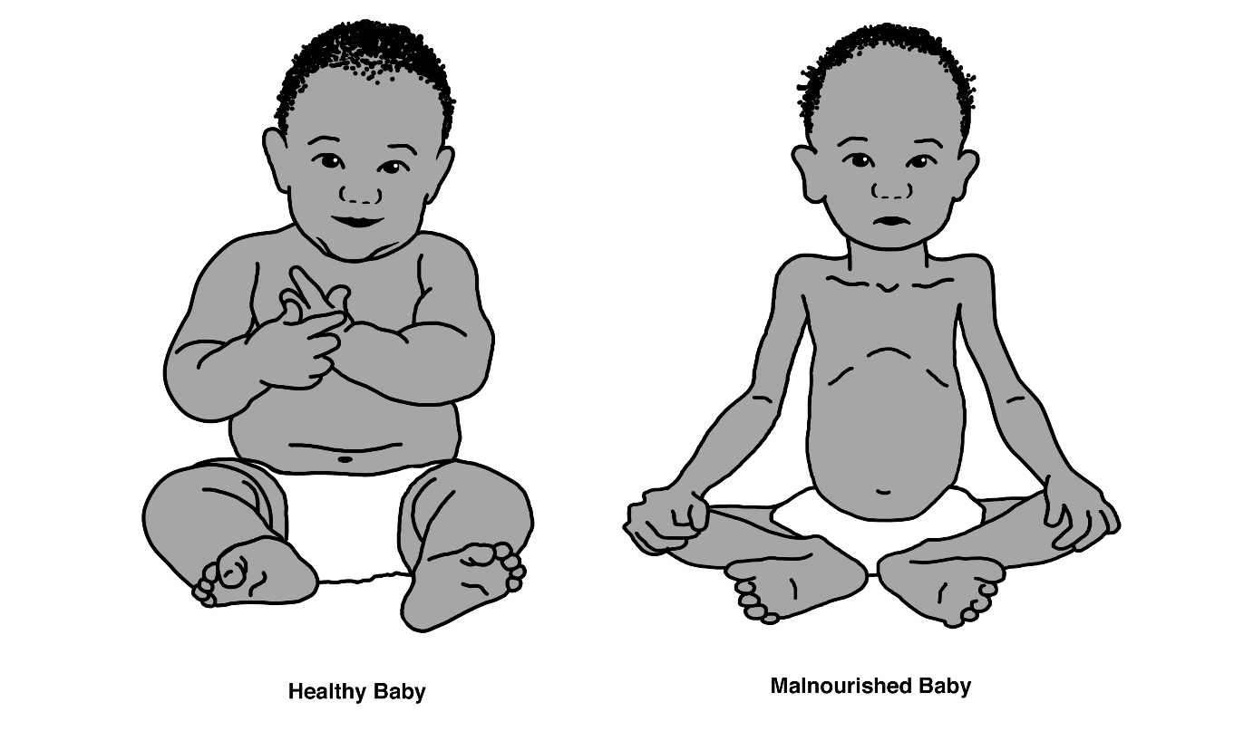
Say: Do you remember the pictures of two babies you saw in an earlier session? One was healthy and the other was unhealthy. The difference between them was that the unhealthy baby was not receiving loving care, but he did have a healthy diet.
For babies to be healthy, they need a number of things. They do need love and care, but they also need nutritious food, immunizations and a clean environment.
- Ask: What are you already doing to help your children stay healthy?
- Ask: How are you caring for yourself and your children when they are sick?
Summarize and affirm the best practices, emphasizing the practices that relate to today’s topic.
Say: Cover your eyes with one hand and raise your other hand if you think this statement is true.
True or false: Hand-washing and keeping your floors, diapers, bottles and bedsheets clean helps your children stay healthy.
Count the number of raised hands. Record it in the “Before Session” column in the True/False Survey (found at the end of this session).
Say: Today, we are going to look more closely at four healthy habits that help prevent common diseases that can delay your child’s development or even lead to death.

Introduce the New Content, Part 1
Immunizations
Say: The first healthy habit is immunizations.
Show a local immunization card (one used by participants preferably) and facilitate a discussion using open questions such as “When?”, “Who?”, “How?”, “Where?” and “Why?” See the following questions for guidance.
- Ask: Who has heard about immunizations or had their children immunized?
- Ask: Why do we immunize babies and children in our community?
After participants respond, spend some time going through the card, point out the immunization schedule and explain how to use it to track immunizations. During the discussion, affirm the following points or advise participants of these points if they are not mentioned.
- Immunizations protect children against deadly diseases.
- You can take children for immunizations even when they are sick, though you should inform the doctor.
Affirm their participation and ideas shared in the discussion.
- Ask: Where can you get information about immunizations if you want to know more about them or get your questions answered?
Share information you collected about the location of the nearest health clinic and any information the clinic distributes regarding immunizations.

Introduce the New Content, Part 2
Breastfeeding and Nutrition
Say: The second healthy habit is breastfeeding and proper nutrition.
There is a proverb: “It is the owner of the body who looks out for the body.” It’s true, we all must be responsible for the health of our bodies. But when your child is a baby, you must look out for your own body and his body.
Show the breastfeeding picture and facilitate an open discussion. See the following questions, picture and the box below for guidance.
Questions for mothers:
- Ask: Who has breastfed a baby?
- Ask: After the baby is born, how soon do you start breastfeeding? Why?
- Ask: How long should a baby receive just breast milk? When do we start adding other foods to a baby’s diet and what do we add?
- Ask: Why is nutrition important for pregnant and nursing mothers?
- Ask: Where can you get more information about breastfeeding if you want to know more about it, or get your questions answered?
Share any information the nearest health clinic distributes regarding breastfeeding.
(Note to Facilitator: If you are working with caregivers in an orphanage or creche where breastfeeding isn’t an option, ask the following questions instead.)
Questions for mothers and caregivers of bottle-fed infants:
- Ask: How do you feed babies before they can eat foods?
- Ask: When you use a bottle, what are some things you should do, and others that you should not do, to ensure the best health for the baby?
- Ask: How old is a baby before she can begin to eat food?
- Ask: What are good foods to feed infants to make them healthy?

Source: World Health Organization

For Nursing Mothers | For Crèche and Other Caregivers
- A pregnant mother should consume more food in terms of quantity and quality since she is supporting the life of a new child.  - Colostrum, the first yellow sticky breastmilk, is very nutritious to babies.  - A mother should breastfeed whenever the baby is hungry. It should be the only food given to babies until the age of 6 months without supplement foods.  - Breastmilk is so healthy that, even when a mother begins to give her baby food at 6 months, she should still continue to breastfeed him until he is 2 years old because it helps him gain body resistance to diseases or sicknesses.  - It is important for a breastfeeding mother to also have protein-rich and nutritious foods. The variety of foods listed below are good foods for the mother too.  - A Haitian proverb: “The baby who does not cry does not need to be breastfed.” This is not true, all babies benefit from breastfeeding. | - Nutrition for babies in crèches and orphanages is very important.  - Babies can be fed by bottle, but the bottle and nipple must be cleaned by boiling them.  - Bottles should never be propped next to the baby, as a baby could choke and even die by inhaling the fluid.  - When using powdered milk, be sure that the water it is mixed with is clean—ideally it should be boiled.
- Sugar is not healthy for babies, and it should not be added to their milk or their water.
- At the age of 6 months, a baby can be given supplement soft foods like porridge and smashed fruits and vegetables.
- Protein and a wide variety of nutrients are vital for babies’ brain development. Healthy foods include beans, eggs, milk, yogurt, lentils, ground nuts, millet, ground corn, fish, meat, chicken, leafy greens, and all fruits and vegetables.
- Well-nourished children are healthier, smarter, happier and calmer.
Affirm their participation and ideas shared in the discussion.

Introduce the New Content, Part 3
Hygiene
Say: The third healthy habit is hand-washing and personal hygiene. Here is a chart that outlines when to wash your hands and how.
Show the hand-washing picture.
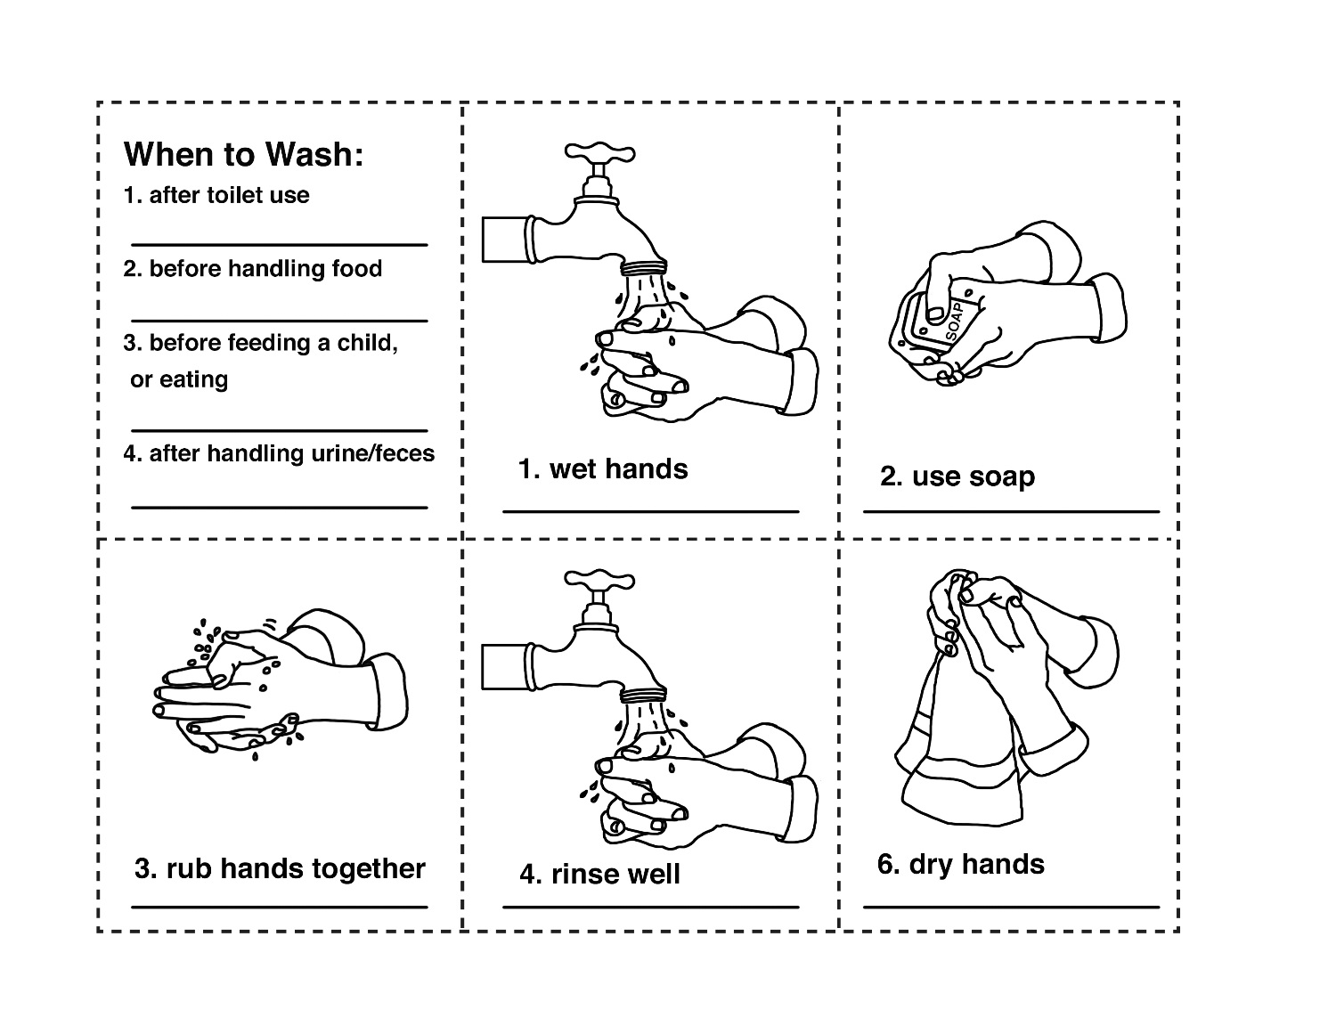

Facilitate an open discussion. See the following questions for guidance.
- Ask: When do you wash your hands? Why?
- Ask: How does hand-washing and cleanliness affect a baby’s health?
- Ask: What are other things that you need to wash regularly to keep yourself, your baby and your home clean?
During the discussion, affirm the following points or advise participants of these points if they are not mentioned.
- There is a proverb: “If you want to win over dirt, you need to bathe thoroughly.” This proverb is very good advice! (Note to Faciliator: if appropriate, replace with proverb familiar to your community.)
- Hand-washing helps in disease prevention, especially diarrhea.
- Brushing the teeth of both caregivers and children is helpful. Another proverb is: “Rotten teeth only have power over [can only bite] ripe plantains.” (Note to Faciliator: if appropriate, replace with proverb familiar to your community.)
- Always use soap when cleaning utensils, washing clothes and washing hands to avoid diseases.
- Babies should not be kept in wet or soiled clothes like diapers or bedding. Clothes should be washed separately to avoid contamination.
- There is a need for mothers and caregivers to take regular baths and wear clean clothes.
Affirm their participation and ideas shared in the discussion.

Introduce the New Content, Part 4
Sanitation and Safety
Say: The fourth healthy habit is sanitation and safety.
Show the picture of diarrhea transmission and facilitate an open discussion. See the following questions for guidance. The box below contains important information to listen for or add to the discussion.
- Ask: What are daily actions you take inside your home to keep your child healthy and safe from illness?
- Ask: What are we doing to reduce the spread of illness and disease in our community?
- Ask: What are the daily actions you take to keep your child safe at home?

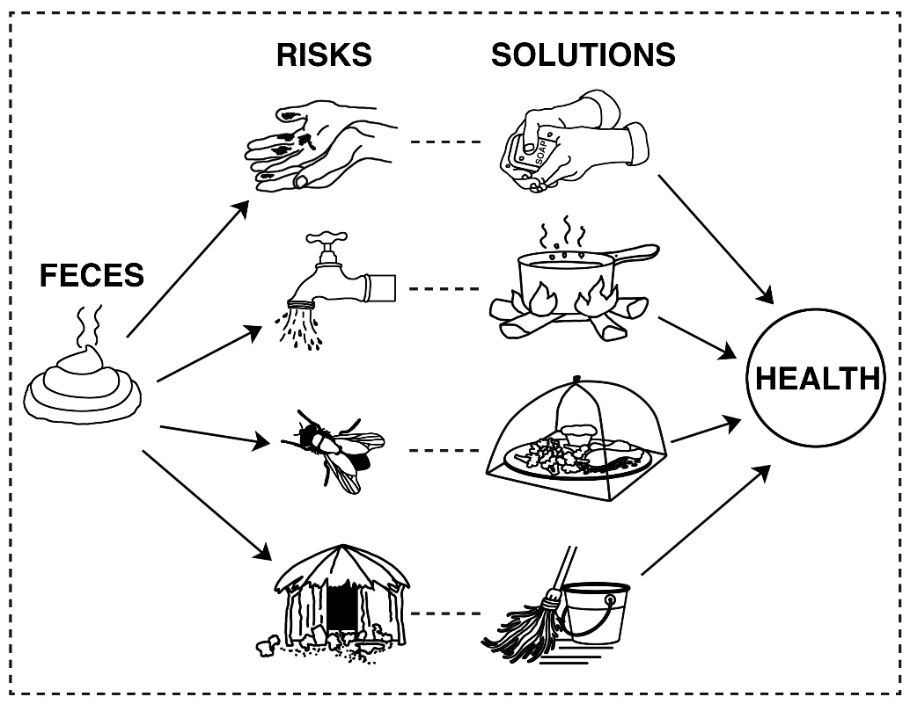
During the discussion, affirm the following points or advise participants of these points if they are not mentioned.

- Wash anything that will come into contact with the child’s mouth, such as dishes, utensils, toys, and fruits and vegetables.
- Keep food covered to keep away flies, which can spread disease.
- Boil drinking water to kill germs. Keep water in clean and covered containers.
- Do not keep animals in the house.
- Always maintain a clean home environment.
- Keep children away from dangers like cooking fires, medicines, drugs and sharp objects to avoid injuries.
- Use mosquito nets, since they help prevent malaria.
- Watch out for choking hazards. Mash food or give food in very small bites, and keep non-edible items such as coins or buttons that children want to put in their mouth away, as they are choking hazards.
- Frequently monitor sleeping babies to check that the bedding is not covering their faces.
- Take precautions with regard to slippery surfaces, hot liquids, electric cords and outlets.
- Remember that safety at home is also about home violence. Children will imitate actions they see and hear. If there is yelling, fighting and hitting in your home, it is frightening for your child, and it is more likely your child will yell, fight and hit, too. Remember that too much and constant stress within the home affects brain development. Think of this proverb: “The giver of the blow forgets, the bearer of the scar remembers.” (Note to Faciliator: if appropriate, replace with proverb familiar to your community.)
- Affirm their participation and ideas shared in the discussion.

- Ask: Where can you get more information about sanitation and home safety if you want to know more about it or get your questions answered?
Share any information the nearest health clinic distributes regarding sanitation and safety.

Apply the New Content at Home
Say: There is a lot involved in keeping your children healthy and safe. We discussed many things today. Think about your own home and family.
- Ask: What is a habit you would like to begin right away?
Affirm participants’ ideas.
Say: Since this is our last session, let’s revisit the true/false statements from all our sessions to see if your opinions have changed or remained the same.
Complete the remaining column entitled “After Session #8” in the True/False Survey by reviewing all true/false questions for all the sessions.
Say: Often, during the day, our children send us cues that they are unhappy. Others within our family or neighbors may criticize us even when we are trying our best with our children.
So, let’s end our final session by reminding ourselves of the great things we are doing as caregivers. Please honor us by sharing one thing you are doing for the babies and children in your care to develop strong brains and healthy bodies and to become loving and caring.
Invite each person in the group to share a self-compliment. Close by sharing something you appreciated about working with the group as a whole.
Say: Let’s sing the “Four Pathways” song for the last time.
Affirm their efforts and thank them for their participation.

Guidance for Using the
Training Delivery Observation Form for Quality Control
The purpose of the following form is to observe the delivery of the education sessions and provide the Facilitator with feedback. The feedback should affirm what the Facilitator is doing well and bring his/her attention to areas for improvement. The goal of the feedback is to help the Facilitator deliver education sessions that will help the participants gain new knowledge, practice new skills and apply this new learning in ways that will improve their lives.
The first column in the form contains the skill areas. There are five skills areas:
- Activity Preparation and Management,
- Technical Content,
- Presentations Skills,
- Facilitation Skills and
- Evaluation.
Each skill area lists actions that will indicate if the Facilitator is maintaining the quality standards in the Observation Form. These actions were chosen because they are observable—they can be seen and/or heard.
The second column is for evaluation. You decide if the Facilitator’s performance in each skill is “satisfactory” or “needs improvement” and write down examples of what was or wasn’t satisfactory.
Focus on areas that the Facilitator does or doesn’t do well consistently as opposed to once in a while.
If the Facilitator needs to improve in many areas, focus on discussing just one or two. It is important not to overwhelm the Facilitator with advice on what to change. Provide specific examples and remember that the feedback should improve the Facilitator’s delivery (if it needs improvement) AND build his/her confidence.

Training Delivery Observation Form for Quality Control
Skills | Satisfactory/Needs Improvement  (Provide Examples)
Activity Preparation and Management
All materials were organized before the session and were easy to access during the activities.
Training space was tidied before the start of the session.
Chairs were placed in a semi-circle.
Implemented all the steps in each activity. Did not replace an activity with a lecture.
Technical Content
Presented all key technical content accurately.
Presentation Skills
Spoke clearly and neither too fast nor too slow.
Ensured that all participants could see the visuals and/or materials

Facilitation Skills
Asked open-ended questions that are the same or similar to the questions written in the sessions.
Used the facilitation skills promoted in the guide. Specifically, affirming and summarizing.
Affirmed trainees’ suggestions and efforts.
Provided participants with enough time to think about and answer questions.
Evaluation
Asked the true/false questions. Recorded the votes in the monitoring form.

Conclusion
We are pleased that you have joined us on this journey. Your commitment to the healthy development of newborns and toddlers is admirable and will have benefits for the participants for years to come. The bond between caregiver and child is unique to that pair. You are helping to develop and strengthen that bond for hundreds of children and families. This is no small feat and none of us can do it alone.
This movement to support and nurture young children is growing all over the world. Long gone are the days when children were meant to be seen but not heard. We know now that children learn and develop by being SEEN and HEARD, long before they are capable of forming words. The World Bank calls early childhood development the very best insurance against poverty. Despite difficult beginnings and seemingly insurmountable challenges, a nurturing beginning full of love and compassion can begin to overcome these challenges.
By supporting fellow Facilitators, parents, caregivers and children, you are directly creating positive change that will last for generations to come. The work you are doing today will have positive effects on health, academic and life outcomes.
As a leader in this movement, you are a source of pride and inspiration. Thanks to you, parents and caregivers will make positive changes in their lives and in the lives of their children. Thanks to you, hundreds of children will get the support and nurturing they need, parents will learn to unlock the power they already have, and communities will thrive with strong relationships and bonds between families.
Thank you for participating in this training.

Resources
Allen, K. E., & Marotz, L.R. (2007). Developmental Profiles: Pre-Birth Through Twelve (5th ed.). New York: Thomson Delmar Learning.
American Academy of Pediatrics, & Remer Altmann, T. (2006). The Wonder Years: Helping Your Baby and Young Child Successfully Negotiate the Major Developmental Milestones. New York: Bantam Books.
Beck, D., Ganges, F., Goldman, S., & Long, P. (2004). Care of the Newborn Reference Manual. Washington, DC: Save The Children Federation.
Bergen, D., Reid, R., & Torelli, L. (2001). Educating and Caring for Very Young Children: The Infant/Toddler Curriculum. New York: Teacher College Press.
Bloomfield, S. (2007, December). Focus on Home Hygiene in Developing Countries. Retrieved April 15, 2010, from International Scientific Forum on Home Hygiene: http://www.ifh-homehygiene.org/2003/2library/Bloomfield_BonnPaper_HH_DvlpingCntries.pdf
Charlesworth, R. (2007). Understanding Child Development (7th ed.). New York: Delmar Cengage Learning.
Cunha, F., & Heckman J. (2007). The Technology of Skill Formation (NBER Working Paper 12840). Cambridge, MA: National Bureau of Economic Research. Retrieved April 17, 2015, from NBER: http://www.nber.org/papers/w12840.pdf
Fernald, L.C.H., Kariger, P., Engle, P. & Raikes, A. (2009). Examining Early Child Development in Low-Income Countries: A Toolkit for the Assessment of Children in the First Five Years of Life. Washington, DC: The World Bank. Retrieved April 17, 2015, from the World Bank: http://siteresources.worldbank.org/INTCY/Resources/395766-1187899515414/Examining_ECD_Toolkit_FULL.pdf
Gonzales-Mena, J., & Widmeyer Eyer, D. (1989). Infants, Toddlers, and Caregivers (4th ed.). Mountain View, CA: Mayfield Publishing Company.
Hart, B., & Risley, T.R. (1995). Meaningful Differences in the Everyday Experiences of Young American Children. Baltimore, MD: Brookes Publishing.
Marie Stopes Health Clinic. (n.d.). Health clinic pamphlet. Kampala, Uganda.
Ministry of Health. (2002, June). Promotion of Immunisation in Uganda: Booklet for leaders.
Ministry of Health. (2007, May). Uganda Policy Guidelines on Infant and Young Child Feeding. Retrieved April 20, 2010, from USAID's Infant & Young Child Nutrition Project: http://www.iycn.org/files/UgandaIYCFpolicyguidelinesfinaldraftMay2007.pdf
Puckett, M.B., & Black, J.K. (2005). The Young Child: Development from Prebirth Through Age Eight (4th ed.). Upper Saddle River, NJ: Pearson.
Trawick-Smith, J. (2006). Early Childhood Development: A Multicultural Perspective (4th ed.). Upper Saddle River, NJ: Pearson.
Twombly, E. & Fink, G. (2004). Ages & Stages: Learning Activities. Baltimore, MD: Paul H. Brookes.
UNICEF. (2005, November 15). ECD Resource Pack. Retrieved April 10, 2010, from UNICEF: Early Childhood Development: http://www.unicef.org/earlychildhood/index_42890.html
Werner, D. (1992). Where There Is No Doctor: A Village Health Care Handbook (pp. 114–118, 230). Berkeley, CA: Hesperian Health Guides.

